2025 Travel Questionnaire Results Summary

During Go Green Week 2025 we asked staff and students participate in a travel questionnaire to get a better understanding of how people travelled to campus.

Over 18% of staff participated which gives a reasonable representative sample. Less than 2% of the student population participated. The information collected in this survey will be used to estimate carbon emissions form commuting for staff, but due to the small sample, data for student commuting will be estimated based on domiciled data from student records.

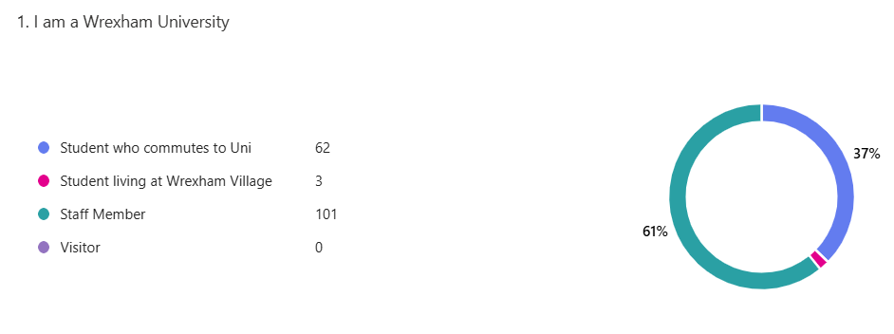
Overall, most staff and students travel to campus 3 days a week or fewer with only 11% of people travelling to campus 5 days a week, the same as reported in 2023. Overall, the split of the number of days attended by staff and students was consistent with the survey carried out in 2023 with approx. 40% staff and students attending campus 3 days a week.

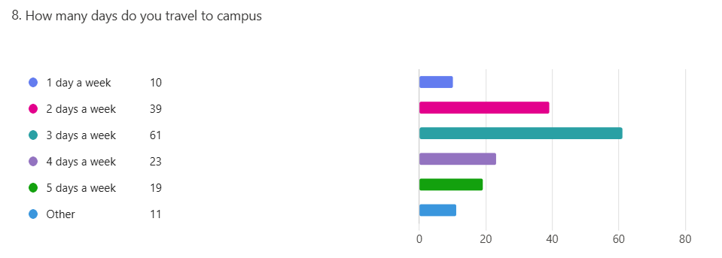

Most staff travelled to work by car with 82% of staff indicated this was their main means of transport. More than 66% of students who participated reported that they travelled to University by train.

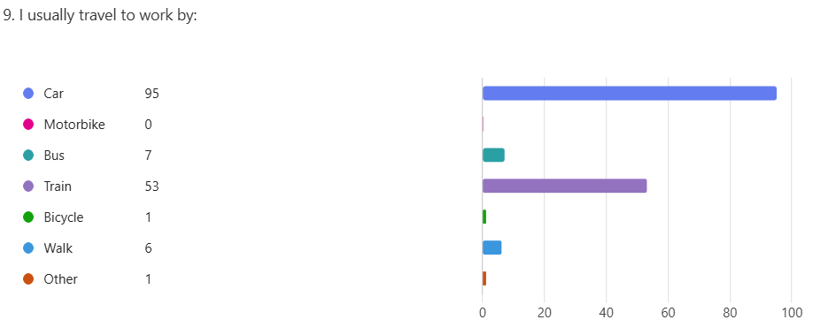

Of car users only 3% of staff that participated reported car sharing on a regular basis, a significant drop from the 13% reported in 2023. From the small sample 50% of students reported that they car share. On average staff that car shared did so under 2 days a week and students shared cars just under 3 days a week.
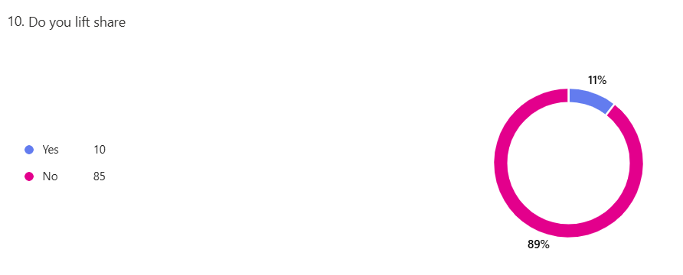

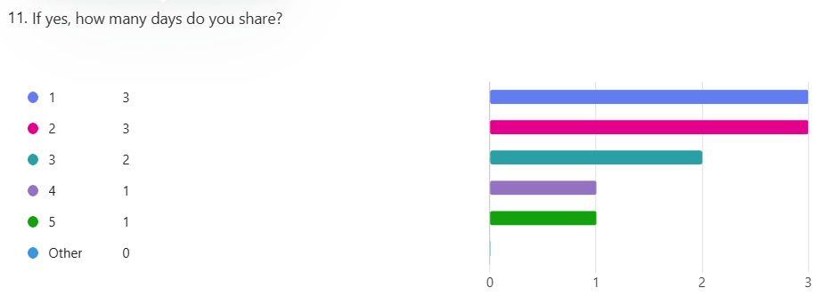

Most vehicles used for commuting are petrol or diesel. Electric vehicles were driven by just under 7% of drivers, which has more than doubled since the last survey in 2023.

The most common reason cited for not opting for a more sustainable travel option was the poor public transport links in the area, poor reliability of the service (train & bus) and cost of public transport. Over 40% of the comments related to the public transport links. 12% of staff drove because of the flexibility it offered them. 5% of staff indicated incentives would encourage them to take more sustainable options. Other reasons cited included the poor cycling infrastructure currently available in the area and lack of facilities on site for bike storage/showers etc.

Overall, all responses indicated that staff travelled over 344,000miles on their regular commute to the University every day. Using this figure to extrapolate an estimate of the miles travelled by all staff working at Wrexham University this equates to nearly 1.9 million miles/year travelling to get to work.

It was not possible to make a reasonable estimate student commuting distance due to the low number of respondents in relation to the total student population.

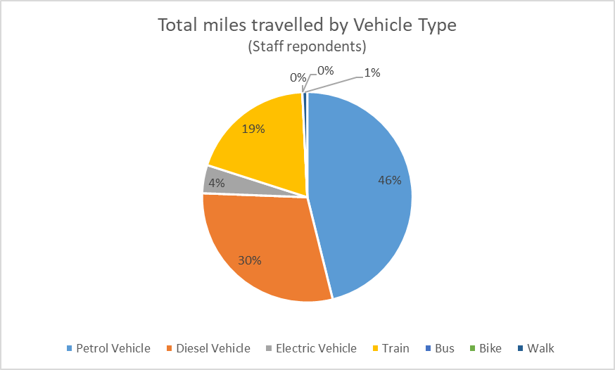

There was not enough student data to make a reasonable estimate of the impact of commuting to University daily or to estimate the impact of travel from their home at the start and end of term for students that live away from home during term time. Data from student records will be used to estimate the Scope 3 emissions from daily student commuting and travelling home at the start/end of term.

