

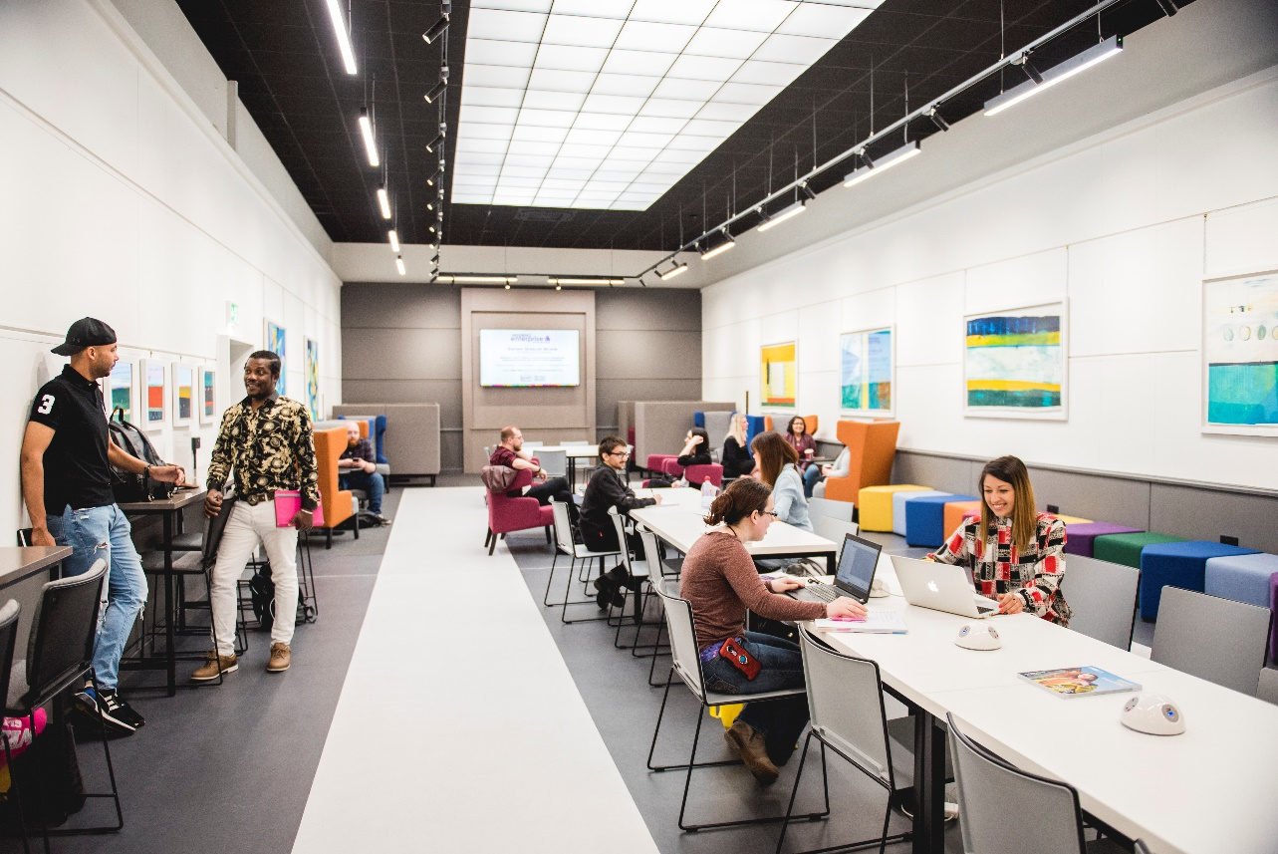

**EQUALITY, DIVERSITY & INCLUSION ANNUAL REPORT 2022-2023**

a varierty of EDI related logo's that showcase the awards and accreditations that the University has received in relation to EDI


Table of Contents

INTRODUCTION 4

EQUALITY, DIVERSITY & INCLUSION OBJECTIVES UNDER THE PUBLIC SECTOR EQUALITY DUTY 4

EQUALITY, DIVERSITY & INCLUSION OBJECTIVES 5

CAREERS & EMPLOYABILITY SERVICE 13

INCLUSION SERVICES 15

CHAPLAINCY 18

DIGNITY AT WORK ADVISOR ROLE 19

STAFF TRAINING 20

EDI EVENTS & ACTIVITIES 23

STAFF DATA 37

BOARD OF GOVERNORS 42

GENDER PAY 43

RECRUITMENT 46

EMPLOYMENT - LEAVERS 49

GRIEVANCE/DISCIPLINARY 51

# INTRODUCTION

This is the twelfth Equality, Diversity & Inclusion (EDI) Annual Report, as required by the Equality Act 2010 and Public Sector Equality Duties (PSED) 2011 for Wales.

A key requirement of the PSED is for the University to publish an annual report on compliance with its duties. This report aims to fulfil this requirement for the academic year 2022-2023.

Further information relating to the University’s Equality and Diversity policies and procedures and other guidance can be found by clicking [here](https://wrexham.ac.uk/about/equality-and-diversity/).

# **EQUALITY, DIVERSITY & INCLUSION OBJECTIVES** **UNDER THE PUBLIC SECTOR EQUALITY DUTY**

Wrexham University (WU) aims to provide an environment that respects and values the positive contribution of its staff, students and visitors; enabling them to achieve their full potential and gain benefit and enjoyment from their student experience. The Equality Diversity and Inclusion objectives that support the reporting period for this document cover the periods April 2020 to March 2024. Equality, Diversity and Inclusion (EDI) underpin the University’s current Vision & Strategy; in particular, its commitments to:

* Accessibility – in the learning we provide for our students, staff and our community; grounded in a dedication to be inclusive and fair in how we provide our services.
* Supporting our interested parties – helping them to gain confidence and achieve their potential.
* Inclusivity – creating a community that welcomes students, staff and visitors from all backgrounds, placing them at the heart of what we do, treating them with dignity and respect and providing equality of opportunity.
* Ambition – recognising that there are no limits to learning; supporting our interested parties with a flexible approach.
* Sustainability – building mutually beneficial relationships with partner universities and further education colleges to meet regional needs in order to support our future growth; in particular in relation to equality, diversity and inclusion.
* Continuous Improvement – developing an inclusive culture within the University, sharing best practice in order to improve our processes and practices to foster inclusivity and develop the diversity of our University community.

The Strategic Equality Objectives support the achievement of the WU mission and values:

**Wrexham University’s Mission**:

To inspire and enable through Higher Education, research and engagement; working together with our students, staff and partners.

**Wrexham University’s values:**

Accessible, Supportive, Innovative and Ambitious.

# EQUALITY, DIVERSITY & INCLUSION OBJECTIVES

The WU EDI Strategic Objectives were created in order to support the University’s Strategic Equality Plan and cover the period 2020-2024. The purpose of our EDI objectives are to strengthen our due regard for the aims of the Public Sector Equality Duty (PSED). The three aims are the need to:

* Eliminate unlawful discrimination, harassment and victimisation and other conduct prohibited by the Equality Act.
* Advance equality of opportunity between people who share a protected characteristic and those who do not.
* Foster good relations between people who share a protected characteristic and those who do not.

The strategy and its objectives establish the University’s commitment to equality, diversity and inclusion under two main themes:

**Objective 1:**

To ensure a learning and working environment that promotes inclusion and equality of opportunity for everyone who studies, works and visits WU.

* 1. **Student Journey** – an inclusive approach to our student’s experience that promotes equality, diversity and inclusion; enabling our students to thrive and leave with the ability to make successful life and career choices.
  2. **Staff Journey** – an inclusive approach to recruitment, progression and the employee lifecycle that promotes equality, diversity and inclusion, enabling our staff to develop and prosper in an environment where they feel treated with dignity and respect.
  3. **Community Journey** – an inclusive learning and working environment that draws on the diverse perspective and cultural wealth of our local community, enabling our community to benefit and grow with the University.

**Objective 2:**

To ensure that the needs of our students and staff are at the heart of the design and delivery of the WU Vision & Strategy and related policies and procedures.

2.1 Demonstrate our due regard for the requirements of the Equality Act 2010 by ensuring compliant policies, procedures and processes in relation to equality, diversity and inclusion.

The strategy enables a focussed approach towards the promotion of EDI and fosters collaboration with interested parties to work towards achieving the aims of the Equality, Diversity & Inclusion Policy for Staff and Students.

As required the University will publish its revised Strategic Equality Plan in April 2024, covering the period 2024-2028; informing future action to support ongoing improvements in relation to equity for staff and students.

The University’s EDI Action Group continue to work collaboratively to achieve the objectives set out within the University’s current Strategic Equality Plan. The plan and its objectives are a standing agenda item at quarterly meetings. The plan is reviewed continuously, taking into consideration current guidance and best practice. The group consists of 23 members and it is chaired by the Executive Director of Human Resources, with student and Board representation.

The equality sub-groups continue to thrive and continue to inform, advise and direct progressive actions in relation to their assigned protected characteristic. The sub-groups allow more directed and meaningful action to take place and include:

* The Accessibility & Inclusion Group
* The EDI Academic Development Team
* The LGBTQ+ Staff Network
* The Race Equality Group
* The Race Equality Discussion Group

**An update on progress made towards achieving the current objectives during academic year 2022-2023 can be found below:**

**Age**

* WU acknowledges a significant percentage of staff and students classify as “mature” and therefore ensures that awareness and support initiatives shared are age appropriate and, where necessary, targeted at older people, those caring for older people or students/staff who network with older people, for example: (1) sharing information re. NHS Safeguarding Wales preventing abuse of older people in Wales (specifically improving services and support for older men experiencing abuse (2) safeguarding adults from exploitation (3) scams targeting the vulnerable (4) an overview of the work of the Older People’s Commissioner for Wales (5) financial guidance.

## Disability

The University maintained Disability Confident employer (Level 2) status, highlighting commitment to the recruitment and retention of our people living with disabilities and health conditions.

Events to help raise awareness and support individuals with disabilities and mental health conditions within the workplace and learning environment during this reporting period included:

* The Inclusion Services Team continued to arrange access provision that addresses potential constraints for those students with disabilities; including mental health and wellbeing issues. Activity included learning support, provision of additional study skills support and improved tracking of student attendance.
* To further support our students the Lead Practitioner for Mental Health and Senior Counsellor offered staff the opportunity to learn how to support students in distress and how to connect them to relevant support in line with University processes. The sessions objectives included (1) raising awareness of issues relating to student mental health, (2) helping staff to recognise when students may be in difficulty or at risk of harm, (3) providing advice to help staff respond/refer appropriately and effectively, (4) reminding staff of the sources of support within the University and (5) helping staff to consider the importance of professional boundaries.
* The ORCHA Platform; a Digital Health App offering a library of resources developed by clinicians was implemented; accessible to students and staff.
* WU has 75 staff members who are licensed to provide Mental Health First Aid to staff and students.
* The University’s TalkCampus Clinical Helpline was launched. The service grants students the opportunity to access mental health support 24 hours per day. The global service is an anonymous and safe platform for students to talk without fear of judgement. The helpline feeds back concerns to the Student Services teams to ensure students with ongoing needs can access appropriate support.
* The Organisational Development & Diversity Team working collaboratively with the Student & Campus Services Team produced a suicide prevention and awareness training video to be delivered to staff to help them to assist and signpost students to support.
* WU acknowledged Suicide Prevention Day (10 September) by holding an event to raise awareness and reduce the stigma associated with suicide. The event showcased the support available from the Samaritans, Mind, Student Services, the WU People and Culture Team and the WU Time 2 Change Champions.
* The Organisational Development & Diversity (OD&D) Team, Student Services and the Student Union hosted a Wellbeing Week during Mental Health Week. The event included pop-up wellbeing stations, Green Social Prescribing, Indian Head massage, and a Well Being Fayre with local wellbeing charities and support groups hosting a variety of stalls.
* Staff were provided with the opportunity to attend Autism Training, supported by the National Autistic Society. The course comprised of two modules and covered Understanding Autism and Autism & Communication.
* WU published a blog written by Tom Cutler, a Learning Support Assistant that detailed his experience of working at the University whilst living with autism, providing insight into why supporting and understanding autism is so vital.
* The University supported three students from Coleg Cambria with work experience placements within our Catering, Reception, and Xplore! teams.
* The Access and Inclusion Group meet to discuss access on campus and within our learning and teaching environments. The Group input and provide advise in relation to building/room lay out plans and accessibility requirements. The group have also provided feedback in relation to the HEIW building plans, ensuring consideration in relation to accessibility has taken place, influencing refurbishment work being undertaken throughout the University.
* An Access Audit was commissioned with outcomes shared with relevant committees.
* During Deaf Awareness Week (May), the University were joined by the Outside-In group as part of “The Conversation: Let’s Talk Disability and Ableism” – Guest speakers were able to share lived experience and provided tips for communicating; with particular reference to online meetings.
* The University hosted RareAware’s #RARExham exhibition in our gallery space. Staff and students were able to view images designed to evoke emotion, and more importantly encourage conversation about rare diseases. Using models with lived experience, each image provided a visible platform for each models voice, telling their story without being hidden behind their rare disease.

## Gender

* Having previously signed the Wellbeing of Women Menopause Pledge, the University continued its commitment to raising awareness and support to students and staff affected by menopause symptoms.
* The admissions processes have been updated to enable students to use their preferred name on their application which provides a more personalised communication experience.
* Following previous initiatives that included social media posts encouraging engagement and promoting the WU offer, resources were shared with local schools to engage their pupils with STEM subject area; linking to females who are successful within the field and interviews with female members of academic staff who teach within STEM areas.
* The Programme Leader for Forensic Science and Forensic Anthropology and Bioarcheology was shortlisted for a 2023 Wales STEM Award. Being recognised for the positive impact she is making towards the STEM agenda in Wales. Shortlisted within the STEM Woman of the Year Category, recognising inspirational woman and their work as ambassadors within the STEM industry.
* The University has maintained White Ribbon Accreditation, with an established action plan being approved (2022) and actions driven by the White Ribbon Action Group. White Ribbon Ambassadors and Champions have been appointed to steer the required activity, raise awareness, connect with local community groups and deliver training to staff and students. The University continues to work collaboratively with North Wales Police to support their White Ribbon Status – with their Community Police Liaison Officers joining the University’s White Ribbon Action Group.
* Staff and students were encouraged to take the White Ribbon pledge on White Ribbon Day (25 November) with white ribbons distributed.
* The University celebrated International Non-Binary Day in July with a serious of infographics and awareness raising pieces circulated internally and via social media platforms. In addition, the a Spotify playlist was shared, featuring selected works featuring non-binary people. Staff and students were also provided with the opportunity to wear a pronoun badge.
* The admissions processes has been updated to enable students to use their preferred name on their application, providing a more inclusive communication experience.
* To date a total of 33 female members of staff have undertaken the Aurora programme with 50% of those being academic members of staff.
* During International Women’s Day a list of fiction written by women was shared with staff; with titles nominated on the longlist for the annual Women’s Prize for Fiction available within the library.
* A review of staff and recruitment data is currently being undertaken by the Race Equality Charter Self-Assessment Team. Their work involves reviewing 3 years of data (primarily focusing on ethnicity), and will include analysis of gender equality to inform initiatives to increase representation.
* To support internal growth and address pay gaps, in particular within senior academic roles:
* The continued delivery of the Effective Programme Leadership course; a modular course aiming to support existing and aspiring Programme Leaders within their academic roles, providing a platform to identify future talent, with female staff being targeted to attend.
* The University has provided 33 female members of staff to date with the opportunity to undertake Advance HE’s Aurora Development Programme.
* The University is a member of the Wales Women in STEM network, which aims to address barriers that face women working in Science, Technology, Engineering and Maths.
* The University continues to review pay gaps in relation to gender, ethnicity and disability on an annual basis.
* Staff and students were invited to attend “Bystander Training” delivered by Brook Training, linked to both hate crime and consent with the objective being to provide attendees with a greater understanding and increased confidence to actively support people experiencing harassment or abuse
* The OD&D team promoted “Safety of Women and Girls on our Streets” via internal communications; a panel discussion featuring Women’s Aid and other sector workers, hosted by Ty Pawb.

## Gender Transition

* The OD&D Team shared information during Transgender Awareness Week (13 – 19 November), via staff communications. During the week, the team shared pronoun badges with staff, promoting awareness and understanding of trans issues and identifying themselves as a safe person to engage in trans related conversation. Pronouns were encouraged on email strips and the LGBTQ+ Network shared a glossary of terminology to assist staff.
* The OD&D Team worked collaboratively with local charity UNIQUE Transgender Network on a number of awareness related ventures, including the delivery of Transitioning Training; an opportunity for staff, students and the local community to attend a session centred around the processes associated with transitioning and how to support and signpost those who may be transitioning.

## Race

* The University continues to work towards achieving Advance HE’s Race Equality Charter (REC). Under the guidance of the appointed REC Project Lead, and with the support of the REC Self-Assessment Team.

Student data is refined and reported to the Senior Leadership Team – including attainment gaps for ethnically diverse students.

* As part of the University’s Race Equality Charter activity, staff and students were asked to complete a questionnaire relating to their own experiences of race equality at WU. Following this the OD&D team hosted focus groups following the quantitative outcomes of the staff and student Race Equality Charter surveys undertaken in May. Staff and students were invited to explore key themes that emerged from the survey outcomes, enabling further discussion and providing meaningful qualitative data to support further improvements.

WU hosted several guest speakers during this reporting period, delivering keynote addresses to both students and staff. These included Ama Afrifa-Tchie (Culture and Inclusion Expert) who spoke to staff and students about race inequality and wellbeing.

* The Youth & Community Team continued to hold “In Conversation” sessions with students and staff, encouraging conversation around Race and Ethnicity.
* To support the University’s inclusive learning and working environment, the Engage Annual Staff Conference 2022 offered staff the opportunity to support the diverse cultural wealth of our community, by inviting staff to attend sessions on culture, race, racism and microaggressions. The sessions both educated and generated important conversations about how to support on a peer-to-peer level – guiding staff to help them to play their part in working towards a more inclusive academic and professional experience at WU.
* During Black History Month (October 2022), the OD&D team shared information and awareness raising resources designed to showcase the University’s race equality work, celebrating black heroes (people who have shaped our culture, our identity, our future, and our history) here in Wales and globally.
* A Youth and Community Lecturer, hosted a session entitled “Think About Racism,” inviting staff at the University to join a conversation about the concept of racism and how terminology, racism in action and racial bias affects people across Wales and the UK. The session’s objective was to detail the issues and then suggest ways to challenge racism and how staff can explore and utilise their own experiences and privilege to support others within their own classrooms, the University as a whole and the community beyond.
* The Race Equality Group (REG) continue to meet and inform improvement in relation to Race Equity.
* The Race Equality Discussion group continue to meet, providing staff of colour with the opportunity to meet and share their lived experience to help to inform improvement.
* The OD&D team commenced the development of a modular training programme focused on race equality, with the first module introducing local historical facts to drive the narrative of the importance of race equality and the REC at WU.
* The University celebrated a blog that had been written by the Deputy Vice-Chancellor, Senior Lecturer in Youth and Community and the Head of Organisational Development and Diversity for Advance HE in relation to race equality at the University. The blog reflected on the WU journey when planning, implementing and reviewing actions required to achieve race equality across the University.
* The OD&D team shared communications in relation to Gypsy, Roma and Travellers History Month, helping to raise awareness of prejudice, myths and amplify the voices of Gypsies, Roma and Travellers in wider society.

## Religion and Belief

* The University is working towards establishing a networking relationship with the Chaplaincy Coordinator at Coleg Cambria, the North Wales Faith Forum and the local mosque.
* The Students Union celebrated Diwali, the festival of light, with information shared with staff about Diwali, providing insight into the history of the Hindu festival.
* Information relating to Passover was shared via internal communications. An infographic offered information to support understanding for those unfamiliar with the Jewish holiday.
* Information about Eid Mubarak was shared with staff and students; raising awareness of this key day within the Muslim calendar, where observers grow spiritually and become closer to Allah (the Arabic name for God) and their loved ones.

## Sexual Orientation

* WU secured Gold Employer status, within the Stonewall Workplace Equality Index ranking, rising from last year’s placement of 47 to 41 - an increase of 374 places since the University’s original submission in 2018. WU is currently ranked sixth in the education sector for LGBTQ+ inclusion.
* To ensure LGBTQ+ staff and students are visibly represented, awareness days linked to the different LGBTQ+ identities were acknowledged and celebrated in various ways.
* During LGBTQ+ History Month (February 2023) the LGBTQ+ Staff Network developed a themed campus hunt, with posters displaying a QR code linked to a variety of infographics that shared details of an LGBTQ+ related event, place or person that had significant impact on the LGBTQ+ community and within history.
* The University was represented at Chester Pride in August 2023, by a number of staff, students and members of the Senior Leadership Team. All staff and students who attended wore WU branded t-shirts designed for the event.
* The OD&D team promoted Pride Wrecsam events, supporting the establishment Pride within the community ahead of their planned Pride event in 2024. Members of the LGBTQ+ Staff Network represent the University at Pride Wrecsam committee meetings, working collaboratively to support planned events.
* To celebrate Pride Month, the LGBTQ+ Staff Network shared information about the Stonewall Uprising and the history of the LGBTQ+ inclusion flag. A visiting Lecturer and LGBTQ+ Staff Network member delivered a session on LGBTQ+ History and Health, exposing myths and creating a safe space for conversation.
* As part of the Rainbow Laces campaign, the University donated Rainbow Laces to Wrexham Rhinos (inclusive rugby team).
* The University strengthened collaborative working opportunities with North Wales Pride, hosting a stand at a North Wales LGBTQ+ Event.

## General

* ALF (Academic Learning Framework) continued to address flexible and inclusive learning to support our students, including those with learning differences. In addition, it promoted good practice in relation to assessment and feedback in a digital environment to promote digital enabled learning environments for everyone, supporting true inclusivity.
* The Academic Development Team (ADT) EDI Group reviewed reading lists and shared a catalogue of diverse reading materials with Lecturers. The Group continue to review the curriculum and develop mechanisms to understand the needs of Minority Ethnic Students and minority groups, in line with the Strategic Equality Plan and Race Equality Plan
* The Students Union launched a campaign entitled “Help Yourshelf”, an initiative set up to support the student community during the cost of living crisis with basic essentials available.
* The OD&D Team shared information relating to Holocaust Memorial Day (HMD), attending a planned event at Wrexham’s Tŷ Pawb (27.01.23).
* Working in collaboration with the Student Advice & Guidance Team and the Students Union, the OD&D team continue to plan coordinated awareness raising events to celebrate key diversity days.
* The OD&D team continue to deliver EDI sessions to student and staff cohorts to further develop their understanding of EDI.
* During National Safeguarding Week (14 – 18 November) the University shared information in relation to safeguarding adults from exploitation (and the mental health effects associated with exploitation) and scams that target vulnerable individuals.
* The OD&D team celebrated both Blue Monday and the Chinese/Luna New Year as a joint awareness raising event as a way to promote positive wellbeing. Staff and students were presented with origami fortune cookies (taking inspiration from Chinese culture) at various points throughout the University containing positive wellbeing statements or Chinese proverbs. Over 150 fortune cookies were handed out.
* To support the wellbeing of staff and students who may have caring responsibilities or who may be experiencing the impact of Alzheimer’s and dementia, the OD&D team and the Parent/Carer Staff Network shared information about the condition and signposted to available support.
* As part of the University’s commitment to support staff and students wellbeing, the OD&D team promoted Alcohol Identification Training, hosted by Alcohol Change; a workshop to support staff, helping them to recognise signs of alcohol misuse and how to support and signpost individuals to further information and help. In addition, during Alcohol Awareness Week, the OD&D team promoted ‘Alcohol and Cost’; an awareness raising campaign coordinated by Alcohol Change with links to a variety of interactive tools and advice to help staff and students assess their own drinking habits. The team also supported the campaign by hosting a stall in the Students Union with resources to share awareness on safe measures and units.
* In February, the OD&D team promoted the National Network for Parents and Carers in Higher Education’s discussion panel about the complexities of fatherhood.
* The University offered staff the opportunity to join a Breathworks accredited Mindfulness for Stress course; taking place over a 10 week period, designed to improve wellbeing and self-care.
* The OD&D team shared information in relation to Stress Awareness Month (April), providing resources with staff to address stigmas that separate mental health from physical health and vice versa. Staff were signposted to mechanisms to manage stress and assess their own mental health.
* The OD&D Team commenced working with Business in the Community (BITC), Money and Pension Service (MAPS) and Age Cymru to ensure WU in an informed position to signpost and share information during the cost of living crisis. Current scope includes Mid-Career review Webinars, and guidance on supporting informed choices for their future regarding career, health & wellbeing, finance and work-life balance.
* Links to national webinars hosted by pensionawarenessday.com (31st October and 4th November) relating to pensions & tax, pension credit and pension schemes were shared with staff.
* The LGBTQ+ Staff Network shared information surrounding the International Day Against Homophobia and Transphobia (IDAHOBIT). Staff were also directed to VS and Zoteria; dedicated online support mechanisms specifically for those identifying as LGBTQ+.
* The Parent/Carer Network Group was launched; aiming to support those staff with caring responsibilities in the workplace, highlighting the support that is available internally and externally, supported by Carers Cymru
* The University was awarded the Victim Support (VS) Hate Crime Charter Trust Mark, to recognise WU as a safe space for victims of hate crime within the community.
* Governor diversity continues to be monitored by the Board’s Nominations and Governance Committee.  The Board committed to the development of a diversity and inclusion strategy with a view to supporting the development of mechanisms to support the recruitment and retention of diverse membership reflected within the Board of Governors.
* To emphasise the University’s slavery and human trafficking statement, the OD&D and HR teams used both Refugee Week and the Remembrance of the Slave Trade and its Abolition awareness day as an opportunity to share information about the impact of the transatlantic slave trade on Wrexham and neighbouring areas.

# A group of women sitting at a table Description automatically generatedCAREERS & EMPLOYABILITY SERVICE

Aligned with our mission to inspire and enable through HE, research and engagement by working together with our student’s staff and partners, the Careers and Employability Service have responded by strengthening core services for all students through continued and consistent efforts to enhance and embed employability into learning and teaching and professional services support services.

During this reporting period the following progress was made towards achieving key strategic priorities:

* All new and revalidated programmes have been aligned with the Graduate Framework; with career development learning activity embedded into the curriculum.
* Established Community Connect volunteering days with 60 organisations supporting events throughout the year.
* Introduced digital self-help portals available for students.
* Created online learning pathways, with over 250 students engaging , supporting the development of their career enhancing skills.
* The award winning Careers and Employability Team continue to offer a range of services, working to help develop confidence, focus and motivation required by learners to achieve their career aspirations and goals.
* Engaged with staff CPD and conferences, raising the profile and embedding employability across the University through increased activity undertaken by the Employability strand of the Academic Development Team.

**Key Achievements**:

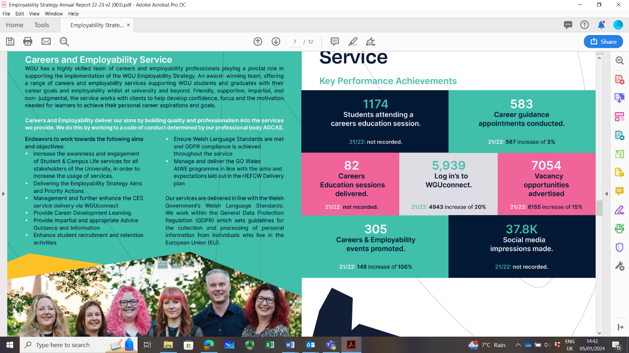

**GRADDddeuol/GRADdual**

Logo of GRADDddeuol/GRADdual as part of the paper
Approximately £115K of HEFCW COVID-19 response funding is providing additional support for those students graduating during the covid pandemic (2019-2022). The Careers and Employability Service have responded to the pandemic through a matrix of tailored support interventions, which complement the Go Wales ATWE Project.

The project provides support for recent graduates to access work experience; 1,046 graduates impacted by COVID 19 were provided with access to support, with 149 of those requiring high level additional support.

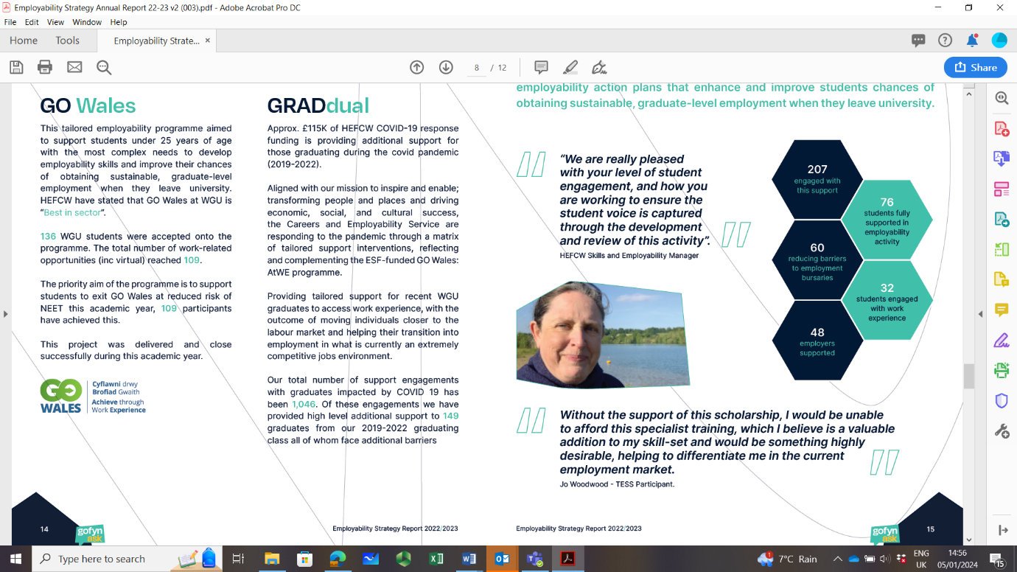

**Target Employability Support**

Introduced in January 2023, tailored employability support was introduced aimed at students with complex needs. Employability Navigators work with individuals to assess learning requirements and develop action plans to enhance and improve their opportunities to gain sustainable employment.

**Go Wales Logo**

**GO WALES ATWE PROJECT**

A tailored progamme, aimed at supporting students under 25 years of age with the most complex needs to develop employability skills and improve their chances of sustaining employment. HEFCW stated that the project was “Best in Sector”, with 136 students accepted onto the programme, with a total number of work-related opportunities reaching 109.

# INCLUSION SERVICES

The Inclusion Services team play a key part in addressing the many barriers faced by the University’s high proportion of disabled students as well as shaping and driving improvements and positively contributing to enhancing and improving the student experience.

The Inclusion Services Team support students by:

* Arranging pre-application visits
* Assessing students for Disabled Students Allowances (DSA) via the in-house accredited assessment centre
* Providing specialist Non-Medical Helper support (Specialist Study Skills and Specialist Mentoring)
* Producing individual schedules of adjustments, detailing appropriate required support e.g. individual exam arrangements.
* Matching students with Learning Support Assistants (Note-takers, Practical Support Assistants and Study Assistants)
* Screening for specific learning difficulties and arranging referrals for formal diagnostic assessment
* Liaising with academic staff on student support and adjustment implementation
* Supporting students to apply for Disabled Allowances funding
* Supporting students with temporary impairments which impact their study
* Working strategically to promote mainstream accessible and inclusive learning
* Promoting disability issues via the EDI Action Group; working collaboratively to achieve the objectives set out within the University’s current Strategic Equality Plan.
* Providing transitional activities prior to enrolment
* Liaising with the Estates and Campus Management Team; advising on required adaptations to student accommodation and teaching and learning spaces

Given the student profile at WU and the range of complex issues presented by many students the support available has a genuine impact upon student learning outcomes. The team work with other professional services teams, ensuring that all elements of support available to students are ‘joined up’ and seamless in approach.

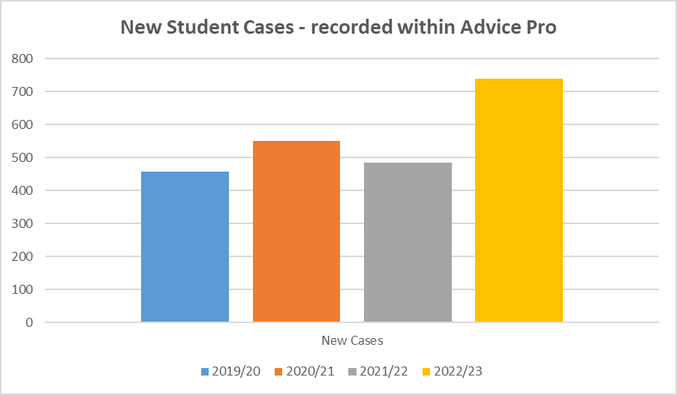 The service continues to work proactively to encourage prospective applicants, offering holders and enrolled students the opportunity to disclose and register as early as possible enabling them to access necessary support and resources. During Academic Year 22/23, the team had a presence at Open Days, Applicant days, transition, and welcome week events, and delivered induction presentations across Faculties. Collaboratively working with the Admissions Team has allowed the Service to take positive action to engage with offer holders earlier in the year once they have received their offer and, where all necessary information has been supplied by the student, to undertake a substantial number of diagnostic assessments and DSA Study Needs Assessments before matriculation.

The chart to the right presents the number of new student cases recorded within Advice Pro (Inclusion Services CRM). Data available for a 4 year period.

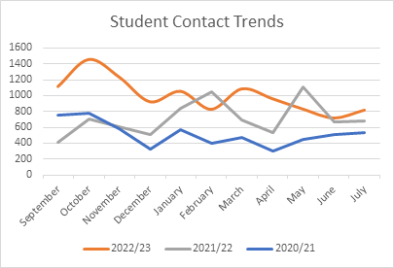The chart below presents the number of interactions with students over a 3 year period.

**Diagnostic Assessments:**

The team offer a diagnostic assessment service for Specific Learning Difficulties (SpLD). During Academic Year 22/23, 129 diagnostic assessments were undertaken; an increase of 24% in comparison to the previous year. The diagnostic assessment is required in order to meet funding body requirements for students to benefit from the extensive funding available via Disabled Students Allowances.

**DSA Study Needs Assessments:**

The in-house Assessment Centre conducted 215 DSA Study Needs Assessments during Academic Year 22/23.

**Non-Medical Helper Support:**

Within Inclusion Services, there are a number of specialist staff available to support students**.** The support is designed to:

* Help understand the particular barriers to learning experienced by individual disabled students
* Work with the student in order to identify strategies to help address these barriers
  + Work with the student to continually monitor the effectiveness of these

strategies

* + Work to enhance student’s autonomy within their learning context

**Learning Support Assistants**

The team of 12 Learning Support Assistants delivered 4,963 hours of support between 1st August 2022 – 31st July 2023. he support roles include Note-takers, Practical Support Assistants, Study Assistants and Examination Support Workers.

**Specialist Study Skills Tutors**

The Specialist Study Skills Tutors delivered 1,842 hours of support during academic year 22/23, a decrease of 15% based on the previous academic year (second year of reporting).

**Specialist Mentors (Mental Health)**

The Specialist Mentors delivered 720 hours of support in academic year 22/23, a decrease of 4% on the previous year (second year of reporting).

## Student Outreach and Engagement

The annual pre-matriculation transition event for incoming disabled students with autistic spectrum conditions and complex mental health needs proved popular and included a range of activities and enabled early interface between students and a range of university services and departments.

This event ensures that this group of students receive personalised support and are provided with information and guidance in a relaxed atmosphere, that allows students to ask questions in a safe environment and encourages social interaction within a small group of other new students and key support staff. Feedback received included:

*“Thank you so much for inviting me to the event, it has made me feel much less anxious about attending Welcome Week. It was great to have a tour whilst the campus isn’t busy and was really helpful to meet support staff and I know where to go for help if I am feeling overwhelmed”*

# CHAPLAINCY

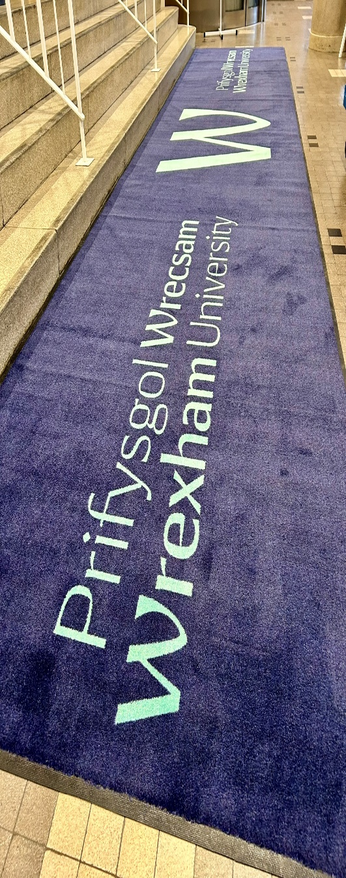

The Chaplaincy Team continue to provide support for the University community. The University has a small team of volunteer Chaplains who are available to meet with students and staff and support those from all faiths and none.

The Chaplaincy is involved in organising events within the University and the local community and highlights this year have included:

* The organisation of a successful Remembrance Day event held in November 2022. This event marked the first face to face event post Covid and was well attended by both staff and students.
* Delivery of sessions for healthcare students focusing on grief, death and bereavement. Chaplains discussed how students can support patients, their families and themselves throughout a difficult period of bereavement.
* Links have been strengthened between the Chaplaincy and other faith groups within the local community such as Coleg Cambria Chaplaincy and St Vincent De Paul.

# DIGNITY AT WORK ADVISOR ROLE

The University’s Dignity at Work Policy and Procedure continues to support staff to ensure an environment where staff can work free from bullying and harassment. The University’s Dignity at Work Advisors support the policy and procedure, listening to staff’s concerns and providing a supportive, confidential and informal platform for staff to discuss issues relating to bullying and/or harassment; signposting them to additional support should this be required.

A chart detailing the number of meetings undertaken by the Dignity at Work Advisors over a 5 year period can be found below, with gender split identified.

We can see a reduction in the number of meetings that have taken place from academic year 2018/19, with a significant increase seen in 2019/2020, which could be connected to a number of efficiency restructures that took place during this period; with staff potentially seeking additional signposting information and support at that time.

# WIDENING PARTICIPATION

****The Widening Access team at WU support those most under-represented within Higher Education. Through funded activity the team strive to widen access to students within our local communities across various settings. As number 1 for social inclusion within the UK, the University recognises that everyone has complex needs and offers information, support, and guidance for those in education.

The Widening Access team have identified core schools and colleges with a high proportion of WIMD (Welsh Index of Multiple Deprivation) students across North Wales to offer a package of support to enable them to access HE.

Through collaboration with schools and colleges that are not classed as core priority, we present opportunities within the university and wider career options through presentations and attendance at careers fairs.

Through Reaching Wider (the Welsh NCOP - National Collaborative Outreach Programme), we offer a multitude of experiences to students identified as under-represented. Reaching Wider change their priority schools yearly based upon the WIMD data. Working with reaching wider enables the University to offer support for the transportation of learners, ensuring they have access to events, helping to raise their aspirations.

Through collaborative working with partners, such as local authority working groups, charities and the Department for Work and Pensions we support local youth groups, estranged students, care experienced students, refugee groups and military families in gaining access to HE provision. As a progression partner within the Adult Community Learning partnership, we support adult learners with one to one advice and guidance around university.

The development of a Recruitment Strategy is currently taking place, aiming to reduce the isolation of students in rural communities and those most at risk of not attaining HE, by attending events/workshops/school invites providing information, advice and guidance, with invitations extended towards them to attend on campus events.

Throughout the year, the team hosted and attended a series of core and funded event opportunities with our institutional partners, such as Reaching Wider; including:

**Core**:

* Multiple visits on and off campus with North East Wales Schools
* Care leavers Week Events
* Quarterly meetings with Wrexham and Flintshire Councils to network and share good practice with organisations supporting learners from becoming NEET
* Quarterly meetings with Wrexham’s ACL(Adult learning Community) to network and share good practice , sourcing opportunities to support adult learners into Education.

**Funded**

* Healthy Careers Project with Coleg Cambria
* Brightside mentoring for year 12 and 13 learners
* STEM Day
* Girls into STEM
* Hay Festival Cymraeg

# STAFF TRAINING

Equality, Diversity & Inclusion training is available to staff, including legislation updating, awareness of protected characteristics and discrimination.

The monitoring of staff training takes place with the following data recorded for the academic years spanning academic years 2018/2019 to 2022/2023.

A summary of staff attendance at training activity can be found above; with a total of 15,530 members of staff attending during the 5 year period. We can see a steady increase in attendance from academic year 2018/2019 to date, which is attributed to the increased programme of CPD available. Professional Services staff have increased levels of engagement with 69% of those attending within this time frame being female; reflective of our workforce demographic.

# EDI EVENTS & ACTIVITIES

In addition a variety of events have taken place within the University to promote inclusivity and raise awareness of Equality & Diversity, including:

* The University remained 1st in the UK for Social Inclusion.
* The University performed strongly in a number of categories within the Guardian Good University Guide, including 1st in the UK for Satisfaction with Feedback and 10th in England and Wales for Satisfaction with Teaching (11th in UK).
* The University were placed 2nd in Wales for Teaching Satisfaction and Overall Satisfaction in the 2023 Times and Sunday Times Good University Guide.
* A Youth & Community Lecturer delivered a presentation exploring the relationship between social justice and multi-culturism in education at the Academic Arab College for Education in Israel.
* During September a Welsh cross collaborative day took place between the University and Coleg Cambria. Staff from both institutions came together to discuss current Welsh provision and share good practice.
* A Youth and Community Work student successfully completed their final year placement at Dynamic Wrexham, where they excelled in developing their practice working with young people aged 11-25 living with learning and physical needs.
* The University’s Head of Public Policy Engagement presented at a national conference hosted by Social Care Wales, exploring storytelling for wellbeing, practice and learning.
* During November the TrACE (Trauma and Adverse Childhood Experiences) Team received a Kindness in Education Award; honouring the activity that has taken place embedding kindness and compassion into all activity at WU.
* Two BSc Mental Health and Wellbeing students acted as panel members discussing disabilities beyond the wheelchair.
* Pupils from local Welsh schools visited the University during January for Welsh Opportunities Day, attending talks from a cross section of academics. The pupils commented that they were encouraged to learn that Welsh provision would be available to them, extending to assessments and pastoral care.
* Working collaboratively with Bangor University and a number of partners the University piloted a scheme entitled the Children’s University, aiming to inspire a love of learning amongst children and young people within the local community. The scheme provides access to extra-curricular activities as part of a shared civic mission commitment, aiming to end social inequity within the region.
* The University were recognised in the What Uni Student Choice Awards; ranked first in Wales for student support, second for lecturers and teaching quality, fourth by International Students and eighth for career prospects.
* In June the University were ranked 2nd in Wales and in the top 10 for student satisfaction within the Complete University Guide for 2024. Nursing was also ranked 1st for student satisfaction for a second year and 1st for graduate prospects in the 2024 subject league table.
* 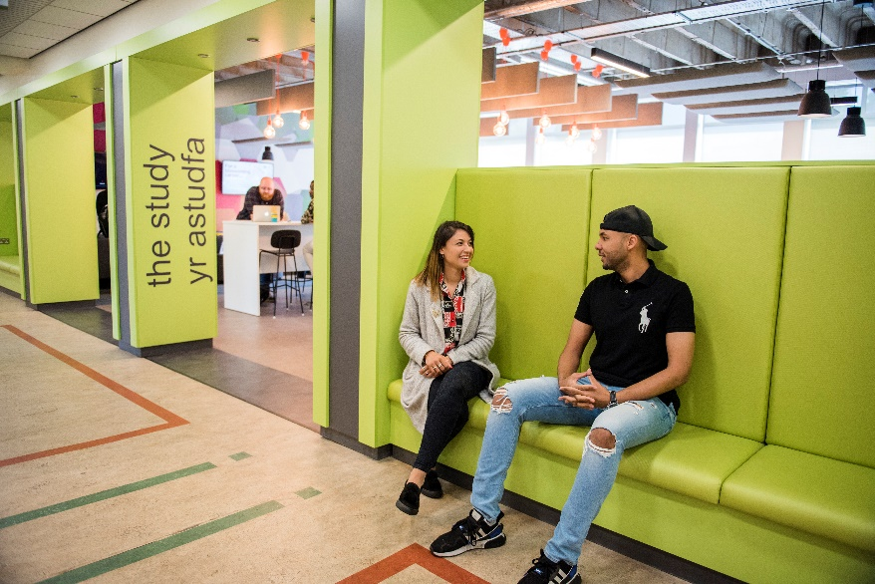A Postgraduate Research student shared their journey towards achieving a PhD whilst living with hearing difficulties and learning differences; inspiring and encouraging others to asp ire to greater things.

# C:\Users\bloomfielda\Pictures\EDI\Student.jpgSTUDENT DATA

*Data provided is based on full academic years. All data has been rounded using HESA’s rounding and suppression rules ** indicates data that has been suppressed.*

The following pages present student data including breakdowns by demographic groups and awards achieved. In 22/23 HESA implemented their Data Futures collection for student data. This necessitated changes to the way that several student metrics are recorded, with several data fields being replaced or updated. As such this means that for a number of reporting metrics included within this section of the report, comparison with previous years is not possible due to the changes to the format of the data. Where year on year comparisons can still be made they have been included.

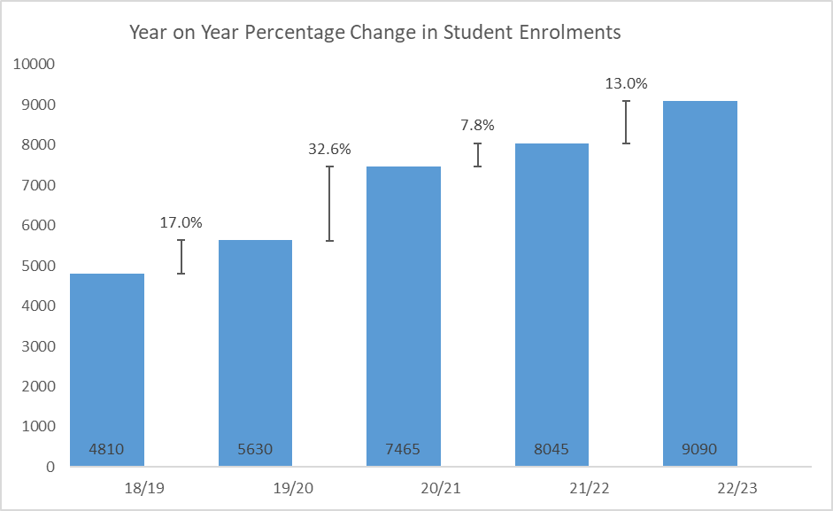During academic year 2022/23 the total number of students was 9,090; an increase of almost 1,000 students on the previous academic year. The chart below presents the student numbers gathered over a 5 year period; with total student numbers increasing by 89% within that period. The most significant increase can be seen between 19/20 and 20/21, with a total 32.6 percentage point increase; largely driven by a 140% increase in WU Online students.

Gender

The following charts present student numbers by mode and gender over a five year period. For information a small number of students did not identify as either male or female within this reporting period, however due to their low numbers they have not been included within this analysis.

For full-time students, whilst overall student numbers have increased there has been no significant change within the split between male and female students within the past three years, the most significant change can be seen between academic years 19/20 and 20/21, with an increase of 5 percentage points for male students seen in 20/21.

In relation to part-time students there has been an increase of 6 percentage points in the number of male students attending, with a decrease of 6.1 percentage points for female students, suggesting that the student population is moving to a position of parity between genders.

Age

The following graphs present the proportion of students by age range across a five year period.

**Age - Full-time**

For both male and female full-time students, there has been an increase across the years in the 21-24 and 25-29 age ranges, with slightly larger percentage point increases for male students (17.3 percentage point difference between 18/19 and 22/23 for ages 21-24). The largest decrease was seen in male, full-time students, of 18.6 percentage points, between 18/19 and 22/23 for age range 18-20, with a 14.5 percentage point decrease for the same age range for female, full-time students.

**Age - Part-time**

The increases and decreases for part-time students of either gender have seen smaller changes than full-time, and have been more variable across the five year period. Between 21/22 and 22/23 there were small percentage point increases for female, part-time students in categories 18-20 (2.9 percentage points), 30-39 (2.9 percentage points) and 25-29 (0.9 percentage points). For male, part-time students, the increases were seen in 30-39 and 40-49 (11.0 and 11.8 percentage points each). Decreases were seen in 21-24 for male, part-time students (14.3 percentage points) and 50-59 for female, part-time students (4.5 percentage points).

**Declared Disability**

The disabilities declared most frequently for 22/23 were dyslexia, dyspraxia or AD(H)D at 24%, closely followed by mental health conditions at 20%. Please note that students are able to declare more than one disability, and each will be counted for the purpose of this proportional representation.

*\*\* For the purpose of this chart, any other disability includes three categories with less than 1% of students declaring this disability (Autistic disorder; Unseen disability e.g. diabetes, epilepsy, asthma and two or more impairments*

**Ethnicity**

The majority of the student population during academic year 22/23 identified as White (64.9%), with 35.1% of students identifying as an ethnicity other than white.

**Sexual Orientation**

The majority (78.9%) of students during academic year 22/23 identified as ‘Heterosexual’, with the second largest category being ‘Bisexual’ at 4.4%.

**Leavers**

**Leavers by Age**

The age range with the highest percentage of leavers is 30-39, at 27.2% for 22/23, however this figure is consistent with the previous 2 academic years. The age group with the largest increase over the five year period is 40-49, with a 7.7 percentage point increase since 18/19. The largest percentage point decrease across the five year period was seen within 18-20 year olds, at 5.5 percentage points.

**Leavers by Gender**

Across the 5 year period, a higher percentage of female leavers can be seen; this correlates with the proportion of female students seen within the total student population, presented within the following table.

**Leavers by Mode of Study**

For all reported years, with the exception of 18/19, a higher percentage of leavers were studying part-time courses, for information 18/19 has the smallest number of leavers in total.

**Leavers by Sexual Orientation**

For information a number of the category titles have changed in relation to sexual orientation, therefore it has not been possible to provide a five year analysis. With reference to academic year 22/23 the largest proportion of leavers identified as Heterosexual (77.5%), with the second largest being Bi/Bisexual, at 4.4%, presented within the following pie chart.

**Leavers by Ethnicity**

The majority of leavers (66.4%) were identified as White ethnicity, which correlates with the proportion of White students seen within the total student population for academic year 22/23.

**Degree Classification**

|  |  |  |  |  |  |
| --- | --- | --- | --- | --- | --- |
| **Degree Classification** | **22/23** | **21/22** | **20/21** | **19/20** | **18/19** |
| Doctorate | 5 | 5 | 5 | 5 | 5 |
| First Degree | 560 | 865 | 670 | 725 | 835 |
| Foundation Degree | 45 | 35 | 35 | 30 | 65 |
| HND/DipHE | 75 | 95 | 110 | 85 | 80 |
| Postgraduate (Taught) | 1395 | 820 | 345 | 175 | 240 |
| Other Undergraduate | 1275 | 995 | 1090 | 970 | 1155 |
| Professional Graduate Certificate in Education | 15 | 40 | 40 | 50 | 40 |

During academic year 22/23 an increase in students achieving a Postgraduate (Taught) of 12.7 percentage points from 21/22 can be seen; whilst First Degree achievement has decreased by 13.7 percentage points.

The majority of students achieving awards identified as white during academic year 22/23, with the exception of postgraduate (taught) with 56.7% of students identifying with an ethnicity that was not white.

**Degree Outcomes Attainment Gap**

An annual Attainment and Completion Report is shared with the University’s Board of Governors, with the latest report shared on the 24th November, 2023, reporting on academic 21/22. The report provides an update in relation to the Awarding (Attainment) Gap and the Completion Gap, a summary of the outcomes of the report can be found below.

**Awarding (Attainment) Gap** – the analysis was structured by level, including data for First Degrees, Other Undergraduate Degrees (for example HNC or Foundation Degrees) and at Postgraduate level, examining degree outcomes for the following student characteristics:

* Age of student at graduation
* Gender
* Ethnicity
* Disability

**Summary of Outcomes**

|  |  |
| --- | --- |
| **Age** | **First Degree**   * Across the UK, the proportion of younger students achieving good degree outcomes was approximately 13% higher than for older students. * In Wales, the gap is smaller, varying between 6% and 9% over the past 6 years. * In contrast, in 2021/22 at WU a greater proportion of older students achieved a good degree outcome, exceeding that of younger students by 10%. * The majority of mature students achieving good outcomes were studying BA (Hons) Social Work: Qualified Status (8%), Bachelor of Nursing (Hons) Adult Nursing (7%), BSc (Hons) Occupation Therapy (7%), or BEng (Hons) Automotive Engineering (7%).   **Context:**  In 2021/22 32% of students graduating with a First Degree were below the age of 25 at WU, compared to 80% on average across the UK and 75% in Wales  **Other Undergraduate Qualifications**  The number of students at Wrexham University aged less than 25 and who achieved an Other Undergraduate qualification in 2021/22 was too low to meet the reporting threshold. As such no meaningful analysis of attainment can be undertaken for Other Undergraduate qualifications based on age in this academic year.   * The trend across the last six years has been for older students to achieve better results, however this had reversed in 20/21.   **Context:**  26% of students in 21/22 who graduated with an “Other Undergraduate Qualification” were below 25 years of age.  **Postgraduate Qualification**   * In four of the years included within this analysis a higher proportion of young postgraduate students have, on average, achieved good outcomes than older postgraduates. However in the last two years, older students have achieved better results, although the gap appears to be narrowing.   **Context:**  In 21/22 only 13% of students graduating with a postgraduate qualification were below 25 years of age |
| **Gender** | **First Degree**   * Across the UK, female students tend to achieve higher degree outcomes than males at First Degree level. * At WU, between 2015/16 and 2017/18 female students tended to achieve better outcomes than male students. Since 2018/19 the trend has reversed with 3% fewer female students achieving a 1st or 2:1 than male students in 21/22. * At WU, between 10 and 15% of graduates from first degrees each year are EU students. These are predominantly male students, who typically achieve good results. Excluding these students from the analysis shows a gap that has been narrowing over recent years and is now showing female students achieving better results (2%).   **Context:**  In 21/22 students graduating with a First Degree at WU, 65% identified as female, 35% as male, and less that 1% identified as neither male nor female.  **Other Undergraduate Qualifications**  Due to the small proportion of students at WU identifying as male and undertaking an Other Undergraduate qualification no meaningful analysis of the attainment gap can be undertaken for Other Undergraduate qualifications based on gender in 21/22.   * Over the past 6 years a higher proportion of male students studying for other undergraduate qualifications (such as a Foundation Degree, HNC or HND) have achieved a distinction or merit than female students.   **Context:**  In 2021/22 74% of students graduating with an “Other Undergraduate Qualification” were female, and 26% were male, however, this split varies significantly between subject areas.  **Postgraduate Qualifications**   * For 5 of the years analysed, a higher proportion of male students studying for postgraduate qualifications have achieved a distinction or merit than female students, however this has reversed in 21/22 with 5% of female students more likely to achieve a good outcome than male students.   **Context:**  In 2021/22 57% of students graduating with a postgraduate qualification were female, 43% were male. |
| **Disability** | **First Degree**   * This analysis compares the attainment gap between students with and without disabilities at WU to the same attainment gap at the 10 UK Universities most similar to WU when looking at the proportion of students with disabilities. * Students with no known disability consistently achieve better results than students with a disability by a significant margin at WU. However, this declined by 9 percentage points in 21/22. * At Universities with a similar proportion of students with a disability the attainment gap has remained relatively stable over the reporting period and sits at 2% for 21/22.   **Context:**  In 2021/22, 22% of Students graduating with a first degree had a known disability*.*  **Other Undergraduate Degree**  In academic years 19/20-21/22 the number of students with and without disabilities has varied significantly over the years reported. However, in general students with no known disabilities tend to achieve better results than those with disabilities.  **Context:**  In 2021/22 10% of students graduating with an Other Undergraduate Qualification had a known disability.  **Postgraduate Qualification**   * Over the reporting period, postgraduate students without a declared disability have tended to achieve better results than those with a declared disability, however this gap has narrowed in recent years and has stabilised across 20/21 and 21/22 with students with a declared disability more likely to achieve a better result by 2%.   **Context:**  In 2021/22 13% of students graduating with a postgraduate qualification had a known disability. |
| **Ethnicity** | **Postgraduate Qualification**   * Over the reporting period, students identifying as white were more likely to achieve better outcomes than students from ethnicity groups other than white. This gap increased significantly in 21/22. * International student enrolments on Postgraduate Taught qualifications have increased over the last three years with 21/22 being the first year to see this impact in terms of student completions. * In 21/22, there were 174 students who completed a Postgraduate Taught qualification who identified with an ethnicity group other than white. 161 (93%) of these were international students. In 20/21 there were 21 students who completed a Postgraduate Taught qualification who identified as an ethnicity group other than white, with 8 (38%) of these being international students.   **Context:**  In 21/22 47% of students graduating with a postgraduate qualification identified with an ethnicity group other than white. Of these, 93% were international students. |

**In Summary**

The ideal outcome for any University would be for no attainment gap to exist between different groups of students. However, for many reasons this is not likely to be achievable, therefore focus should be directed towards gaining further understanding of the issue with a view to reducing gaps in attainment wherever possible.

The analysis undertaken provides some knowledge and insight to underpin an on-going strategy to lessen the attainment gap between different groups of students.

It should be recognised that it is far from a definitive analysis of the issues impacting on different groups of students, some of which will be outside of the University’s control or influence.

In addition, it should be understood that time series analysis is most useful when the student cohort remains static in terms of student characteristics. This is not the case at WU with changes to the mix of programmes offered and the type of student enrolled (Level 3 vs Level 4 entry for example) over the period of this analysis. With a relatively small student cohort small changes to type of student enrolled or type of course offered can have a significant influence on outcomes.

Of the four student characteristics considered by this analysis, the greatest attainment gaps can be seen when comparing students at postgraduate level by ethnicity and first degree students by age. In addition, the analysis suggests that more could be done to support younger students (at first degree level) and female students (at undergraduate level).

# STAFF DATA

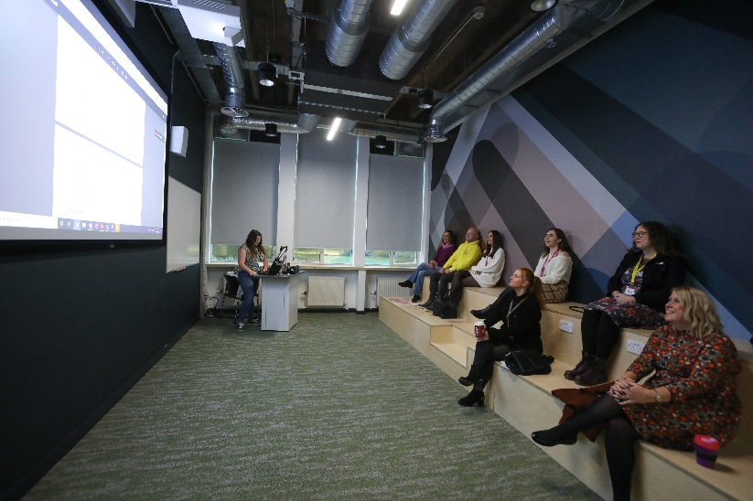A break-down of employment information relating to academic years 2018-2023 can be found within the remainder of this report, it should be noted that these figures do not include sessional and casual members of staff in line with HESA reporting requirements. The following data was captured between the dates of 1 August 2018 to 31 July 2023.

Within this 5 year period we can see an overall increase in staff numbers of 15%, with an average of 61% of staff identifying as female within that period. Our current staff demographic consists of 37% identifying as male and 63% identifying as female, which is slightly higher (+2%) in comparison to previous years.

The percentage of staff with declared disabilities currently presents at 5%. From 2018/19 we can see a 7% average in the number of staff who do not identify as white, which presented at 7.6% within this reporting period. Lesbian, Gay and Bi representation has increased by 3% with 7% of staff now identifying. We are pleased to see the increase in declarations made by staff who identify as LGBTQ+, with focussed work being undertaken to promote an inclusive working environment. Further work is required to increase the number of staff from ethnic groups other than white and those with disabilities, which is a continued key focus.

## GENDER - Staff

The data reflects a total increase of 15% in permanent members of staff over a 5 year period, with a 17% increase in females and 11% increase in males seen within that time.

Over this period we can see that on average during each academic year that 63% of the University’s workforce identify as female, which is higher than the UK and Welsh national average which currently sits at 55%. Women remain underrepresented amongst academic senior posts, STEM subject areas and in senior management roles across UK HEI’s.

Role categories have remained fairly consistent within the 4 year period from 2018/19 to 21/22, with a 15% increase seen in staff during academic year 2022/23, which is reflected in the increase seen across academic and professional services roles, presented above. We can see a significant increase across both female staff working within both academic and professional services areas during academic year 2022/23, with a 44% increase seen within academic roles, this could be attributable to the increase in health related subject areas introduced during this year, which are typically led by those who identify as female.

## Age by Gender

The age profile of our staff has remained fairly consistent year on year within the 5 year period from 18/19 to 22/23. The largest increase can be seen within the age range 21-30 years old in both female (+32%) and male (+45%) staff members. The age range with the greatest number of staff in both female and male can be seen within those aged between 41 and 50 years of age.

**Disability**

|  |  |  |  |  |  |  |  |  |  |  |
| --- | --- | --- | --- | --- | --- | --- | --- | --- | --- | --- |
| **Disability %** | **2018/19** | | **2019/20** | | **2020/21** | | **2021/22** | | **2022/23** | |
|  | **Female** | **Male** | **Female** | **Male** | **Female** | **Male** | **Female** | **Male** | **Female** | **Male** |
| No known disability | 53.4 | 34.7 | 55 | 35.3 | 52.4 | 35.8 | 53.9 | 36.7 | 55.9 | 33.8 |
| Two or more | ** | ** | ** | ** | ** | ** | ** | ** | ** | ** |
| Specific LD | 0.9 | 0.9 | ** | ** | ** | ** | 0.7 | ** | ** | ** |
| Long standing illness | 2 | ** | 1.8 | ** | ** | ** | ** | 1.5 | ** | ** |
| Mental Health | ** | 0.9 | ** | 0.9 | ** | ** | ** | 0.7 | ** | ** |
| Physical Impairment | ** | ** | ** | ** | ** | ** | ** | ** | ** | ** |
| Social Impairment | ** | ** | ** | ** | ** | ** | ** | ** | ** | ** |
| Not listed above | ** | ** | ** | ** | ** | ** | ** | ** | ** | ** |
| Information refused | 2.7 | 1.5 | 1.8 | 1.3 | ** | ** | 1.4 | 1.5 | ** | ** |
| Total | 61.1 | 38.9 | 61.2 | 38.8 | 60 | 40 | 60 | 40 | 63 | 37 |

*\*\* In order to comply with data protection legislation it has been necessary to replace numbers with asterisks. The bottom line figures will not reflect total numbers shown due to redaction.*

The disability profile of our staff has remained consistent within the 5 year period from 2018/19 to 2022/23. 5% of our workforce currently have a declared disability, presenting a 1% decrease within the last academic year, however this percentage remains lower than the HEI UK national average of 7% and HEI Welsh national average of 8%. Among both professional and academic staff (HEI UK Nationally) the most frequently disclosed impairment types were long-standing illness or health condition, which correlates with those conditions disclosed by staff at Wrexham University.

**Ethnicity**

The chart to the left presents the ethnicity profile by %, of staff employed at WU over a 5 year period. In order to comply with data protection legislation it has been necessary to compare total numbers of those who identified as white and aggregate all remaining ethnicities into one figure, entitled non-white.

During this reporting period 7.6% of the University’s workforce identified with an ethnicity that isn’t White; 4.6% lower than the UK National Average of 12.2% and 2% higher than the Welsh National Average of 5.6%. The largest non-white ethnic group at the University was Asian, which is consistent with the UK and Welsh National Average.

Staff working in HEI’s have increasingly become more ethnically diverse, with an increase UK wide; most pronounced among academics, which is consistent with the WU Workforce. Inequalities persist nationally with lower proportions of both UK and non-UK ethnically diverse staff than white staff on permanent contracts, in senior management positions and on higher salary bands and this is consistent with the demographic of staff at WU. Work continues to attract a more diverse workforce to the University with dedicated objectives included within the People Strategy and the recently implemented Race Equality Charter Action Plan to address this.

**Religion**

An increase of 11.8% can be seen in the number of staff who declared that they do not have a religion within the 5 year period from academic year 2018/19. Data reflects that Christianity accounts for the largest proportion of staff with faith, with a small decrease seen within the 5 year period of 0.5%. We can see a small increase in those staff who have Muslim and Hindu faith. The UK wide data reflects that similar patterns can be seen across UK HEI’s.

**Sexual Orientation**

In order to comply with data protection legislation it has been necessary to compare total numbers of those who identified as Heterosexual and aggregate Lesbian, Gay and Bisexual (LGB) staff into one figure. We can see a 3% increase from academic year 2018/19, with the number of staff who openly declare their sexuality low in comparison to those who identify as heterosexual. We are pleased to see that the percentage of staff who have refused to provide their information has reduced over the years (-11%), which is encouraging and reflective of the supportive activity that has been undertaken to ensure that all LGBTQ+ staff feel supported within their working environment here at WU.

## MATERNITY/ADOPTION

It is not possible to report on maternity and adoption due to the low numbers involved in line with data protection legislation.

# BOARD OF GOVERNORS

The diversity of the Board of Governors continues to be monitored by the Board’s Nominations and Governance Committee.  During academic year 2022-23 21 members served on the Board, 11 of whom were female (52%) and 10 of whom were male (48%). The University commenced the gathering of data in relation to the Board of Governors during academic year 2019/2020. The gender balance has remained fairly stable for the last four years and slightly above that seen across all Welsh and all UK universities. The latest available data published in 2022 showed that in Welsh universities 47.2% of governors were female and 52.8%, were male and in UK universities 42.5% of governors were female and 56.8% were male.

During academic year 2022-23 100% of the University’s governors had UK nationality compared to 94.9% across all Welsh universities and 91.9% across all UK universities; 95% were of white ethnicity compared to 92% across all Welsh universities and 87.8% across all UK universities. In terms of age 9.5% (8.1% Wales and 6.5% UK) of the University’s governors were under the age of 25; 76% (68.5% Wales and 73.9% UK) were aged between 26 and 65 and 14.3% (23.4% Wales and 19.6% UK)) were aged 66 and over. Finally, 9.5% of the University’s Governors had a known disability compared to 11.7% across all Welsh universities and 5.8% across all UK universities.

Whilst the Board has always sought to remove barriers that might deter people from different backgrounds, and those with protected characteristics, from applying to become Governors, the Board recognises that it needs to do more to increase the diversity of the Board and reflect the University’s student population. The Board remains committed to improving its diversity and continues to work towards implementation of its Action Plan in this respect.

Leman J (2022) Advance HE: Diversity of HE Governors in Wales <https://www.advance-he.ac.uk/knowledge-hub/diversity-governors-higher-education-2022> (accessed 18/12/23)

# GENDER PAY

The gender split of the University’s staff is 63% female and 37% male.

The mean gender pay gap for the whole organisation is 3.3% in favour of males, with the median gender pay gap standing at 2.9% in favour of males. This compares favourably with the previous reporting period where the mean gender pay gap stood at 6.38% in favour of males and the median gender pay gap stood at 1.97% in favour of males. According to analysis carried out by Times Higher Education, the mean average pay gap across the HE sector stands at 15.9% in favour of males. The Times Higher also report that the median pay gap across the HE Sector stands at 14.8%.

**All Staff Mean Hourly Rates**

| Males | Females |
| --- | --- |
| £20.49 | £19.81 |

**All Staff Median Hourly Rates**

| Males | Females |
| --- | --- |
| £19.41 | £18.84 |

The mean and median gender pay gaps calculation is based on the mean and median hourly pay rates for all substantive staff employed on 1st August, 2022. This shows the difference in average earnings (in terms of mean and median earnings) between women and men across the University. On average based on the mean gender pay gap calculation women are paid £0.68 per hour less than men. Based on the median calculation women are paid £0.57 per hour less than men. The mean figure compares favourably to the 21/22 figures of £1.37 with the median decreasing slightly from £0.58.

## Proportion of males and females in each pay quartile

|  | **22/23** | **22/23** | **21/22** | **21/22** |
| --- | --- | --- | --- | --- |
| **Female** | **Male** | **Female** | **Male** |
| **Upper Quartile** | 58.50% | 41.50% | 57.02% | 42.98% |
| **Upper Middle Quartile** | 60.80% | 39.20% | 61.98% | 38.02% |
| **Lower Middle Quartile** | 66.20% | 33.80% | 60.00% | 40.00% |
| **Lower Quartile** | 59.80% | 40.20% | 65.83% | 34.17% |

Movement in the upper quartile shows an increase of 1.48 percentage points for females and a corresponding 1.48 decrease for males from 21/22. The upper middle quartile shows a slight increase (1.18%) for men and a corresponding decrease for women from 21/22. The upper quartile and upper middle quartile remain almost static compared to 21/22. We have seen an increase of 6.62 percentage points in females in the lower middle quartile compared to 21/22, This can be attributed to more female lecturers being appointed following the introduction of the HIEW contract. Based on the overall gender split of the organisation, we have seen a significant shift of in the lower quartile with a noteworthy increase of 6.03% males in the lower quartile and we can see the gap is beginning to bridge.

Previous year’s reports have shown (as does this year) that there is a higher proportion of females in the upper quartiles. Previous year’s reports have also shown that there has been a higher proportion of males in senior roles within the academic staff group, from Principal Lecturer upwards. This is a known phenomenon across HE where there is an under representation in female senior academics rather than a disparity in rates of pay between males and females doing the same work.

Notwithstanding this known phenomenon that the male/female gap within the senior academic group currently stands at 2.5 in favour of females (11.6 males 14.1 females) an increase of 2.6 compared to 21/22.

The paragraphs below illustrate the activity that has taken place to address the gap that previously existed. It is worth pointing out that the very first Annual Pay Policy Statement published in 2017/18 showed a gap of 12.7 in favour of males for this group (21.1 males 8.4 females). In particular in 17/18 the report showed that 11.6 of the University’s Principal Lecturers were male and only 3.6 were female. This year’s report shows that we now have 6.7 females and 6 males in the Principal Lecturer grade. This comparison clearly demonstrates the success and value of the work undertaken as set out below.

The University continues to develop specific development programmes aimed at staff aspiring to leadership/management level; to incorporate both academic and professional services staff.  Female staff who have expressed promotional aspirations are encouraged to attend tailored developmental programmes to provide opportunities to enable them to apply for future management/leadership roles within both professional services and academic roles.  This is addressed by using the following methods:

* Continued delivery of the Future Leaders Programme during this reporting period; a modular course which included topics such as Leadership Styles/Philosophies, Influencing and Coaching. A targeted approach is taken towards attendance, with those female staff who have either self-identified or been nominated by their line managers being approached to enrol.
* The University has to date provided 33 female members of staff with the opportunity to undertake Advance HE’s Aurora Development Programme. to internally support the selected staff members, members of the Executive Leadership Team and previous Aurora delegates act as mentors and role models to the group.
* The continued delivery of the Effective Programme Leadership course; a modular course aiming to support existing and aspiring Programme Leaders within their academic roles, providing a platform to identify future talent, with female staff being targeted to attend.
* The University introduced a mentorship scheme aimed at all staff; providing the opportunity to identify female members of staff who would benefit from shared experience with a female mentor.
* The University is a member of the Wales Women in STEM network, which aims to address barriers that face women working in Science, Technology, Engineering and Maths.

**Ethnic and Disability Pay Gaps**

The Ethnic pay gap is minus 6.29%, this means that on average staff from ethnic groups other than white are paid 6.29% more than staff who are white (a decrease of 2% from 20/21). This is due to the prevalence of staff from diverse ethnicities working in higher paid academic roles, the majority being graded at Senior Lecturer and above.

The Disability pay gap is 7.48%, this means that on average staff who have declared a disability are paid 10.25% less than non-disabled staff (a 2.77% decrease in comparison to 21/22 figures). A third of staff who have declared a disability are graded at OA5 and below. One member of staff on a senior staff grade has declared a disability.

The University is a Disability Confident Employer (currently working towards Disability Confident Level 3) and collects the following data from employees and applicants with disabilities, which is used to inform and develop positive action plans to measure and address inequalities linked to disability within our workforce:

* + Recruitment and promotion
  + Pay and remuneration
  + Grievances
  + Disciplinary action
  + Dismissals and other reasons for leaving

The following EDI Staff groups have been established whose work involves exploring and addressing inequalities experienced by staff with disabilities and those who identify as an ethnicity other than white and their work will involve scrutinising pay gaps:

**Accessibility and Inclusion Group -** The Group’s membership consists of academic staff, professional services staff, student and external representation. The group is responsible for supporting and informing the work of the EDI Action Group through consultation and discussion of disability matters.

**Race Equality Group -** The Race Equality Group is exploring and developing methods to support the University on its journey toward race equality. The group is responsible for raising awareness, informing policy, educating other staff and celebrating the diverse mix of ethnicities that exist within our University community.  The group are currently supporting the work required to apply for Advance HE’s Race Equality Charter.

**Race Equality Charter Self-Assessment Team (SAT) –** The team evaluates racial inequalities and barriers in representation, progression, development and success of staff and student of ethnicities other than white. The SAT have formulated an action plan to address the inequalities and barriers, that will drive positive long-term impact and cultural change.

# RECRUITMENT

The following data reflects the recruitment activity undertaken during a five year period, from 01/08/18 to 31/07/23. During this reporting period a total of 6,247 online applications were received, with academic year 2022/23 seeing the largest number of applications (1,489), attributed to the need to recruit to a number of specialist roles and utilisation of a variety of methods to advertise. We can see an increase of 29% in online applications between academic year 2018/19 and 2022/23.

Online applications by gender can be seen within the above chart, with an increase of 5.3% seen in female applicants and a 4.6% decrease in male applicants seen from the previous academic year. A summary of applications by role category can be found below, with a significant increase year on year seen in female applicants for professional services roles.

A decrease of 7.7% can be seen in the number of applications received by those aged between 21 and 30 within the 5 year period, with a 2.8% decrease seen in applications received by individuals aged between 51 to 60.

|  |  |  |  |  |  |
| --- | --- | --- | --- | --- | --- |
| **%Application by Religion** | **2018/19** | **2019/20** | **2020/21** | **2021/22** | **2022/23** |
| **Any other Religion** | 1 | 0.87 | 1.2 | 0.5 | ** |
| **Buddhist** | 1 | 0.71 | 1 | 1.1 | 1.7 |
| **Christian** | 38 | 34.34 | 31.4 | 31.2 | 32.2 |
| **Hindu** | 2 | ** | 2 | 3.7 | 3.3 |
| **Jewish** | 1 | ** | ** | ** | ** |
| **Muslim** | 5 | 3.64 | 7.3 | 9.7 | 5.7 |
| **No Religion** | 41 | 49.13 | 46.3 | 41 | 45.3 |
| **Sikh** |  | ** | ** | ** | ** |
| **Spiritual** | 3 | 2.14 | 1.6 | 2.8 | 1.6 |
| **Prefer not to say** | 8 | 8.31 | 8.9 | 9.8 | 9 |

We can see a decrease of 5.8% in the number of applicants who declared that they had Christian faith (consistent with the general census), a 4.0% decrease in those with Muslim faith and a 4.3% increase in those with no religion.

|  |  |  |  |  |  |
| --- | --- | --- | --- | --- | --- |
| **%Application by Sexual Orientation** | **2018/19** | **2019/20** | **2020/21** | **2021/22** | **2022/23** |
| **Bisexual** | 3 | 2.61 | 4.3 | 5.4 | 5.8 |
| **Gay** | 1 | 1.58 | 1.6 | 1.8 | 0.9 |
| **Lesbian** | 1 | 1.03 | 1.14 | 1 | 1.3 |
| **Heterosexual** | 86 | 88.13 | 85.4 | 84.6 | 84.1 |
| **Prefer not to say/**  **Unknown** | 8 | 6.65 | 7.3 | 7.1 | 7.9 |

An increase of 3% in applicants who identify as LGB can be seen during the 5 year period, with the most significant increase seen in those who identify as Bisexual (+2.8%).

|  |  |  |  |  |  |
| --- | --- | --- | --- | --- | --- |
| **%Application by Disability** | **2018/19** | **2019/20** | **2020/21** | **2021/22** | **2022/23** |
| **Disability** | 7 | 5.46 | 6.4 | 6.4 | 9.6 |
| **No Disability** | 89 | 90.66 | 90.1 | 89.6 | 86.6 |
| **Prefer not to say/Unknown** | 4 | 3.88 | 3.5 | 3.9 | 3.8 |

An increase of 2.6% can be seen in the number of applicants who have a declared disability within the 5 year reporting period, which is encouraging following the positive action taken in relation to the University’s commitment to their Level 2 Disability Confident status.

|  |  |  |  |  |  |
| --- | --- | --- | --- | --- | --- |
| **%Application by Ethnicity** | **2018/19** | **2019/20** | **2020/21** | **2021/22** | **2022/23** |
| **Ethnicity other than White** | 16 | 14 | 22 | 25 | 24.7 |
| **White** | 84 | 86 | 78 | 75 | 75.3 |

We can see an increase of 8.7% in applications from individuals with ethnicity’s other than white, consistent with the previous 2 academic years. Increasing the diversity of our staff profile is a key objective within the University’s Strategic Equality Plan, Race Equality Charter Action Plan and People Strategy, therefore this is encouraging data.

# EMPLOYMENT - LEAVERS

The following data was captured between the dates of 1 August, 2018 to 31 July, 2023.

## Leavers by Gender

The data reveals that a total of 297 members of staff left employment during the 5 year period, with a breakdown by gender below.

|  |  |  |  |  |  |
| --- | --- | --- | --- | --- | --- |
| **%Leavers by Gender** | **2018/19** | **2019/20** | **2020/21** | **2021/22** | **2022/23** |
| **Female** | 61 | 71 | 51 | 63 | 51 |
| **Male** | 39 | 29 | 49 | 37 | 35 |

## Leavers by Age

## The % of leavers by age demographic can be found below, highlighting % increase/decrease from academic years 2018/19 to 2022/23.

|  |  |  |  |  |  |  |
| --- | --- | --- | --- | --- | --- | --- |
| **%Leavers by Age Profile** | **2018/19** | **2019/20** | **2020/21** | **2021/22** | **2022/23** | **% increase /decrease from 18/19 to 22/23** |
| **20 & Under** | ** | 0 | 0 | 0 | ** | ** |
| **21-30** | 8 | 10.1 | 16.9 | 23.1 | 10.5 | +2.5 |
| **31-40** | 29 | 24.6 | 24.7 | 23.1 | 22.1 | -6.9 |
| **41-50** | 24 | 20.3 | 27 | 16.9 | 30.2 | +6.2 |
| **51-60** | 20 | 27.5 | 12.4 | 24.6 | 19.8 | -0.2 |
| **61-65** | 14 | 10.1 | 9 | 7.7 | 9.3 | -4.7 |
| **66 & Over** | 2 | 7.2 | 10.1 | 4.6 | 7 | +5 |

## Additional Information

No significant changes can be seen with regards the disability and ethnicity (presented below) of staff who have left the employment of the Institution. We can see an increase of 18.2% in the number of leavers with an identified religion and a 10% decrease in the number of leavers who refused to share their sexual orientation.

# GRIEVANCE/DISCIPLINARY

Due to suppression thresholds, we are unable to publish data relating to Grievance and Disciplinary, in order to protect the identity of those involved.

**WU – inspiring and enabling through higher education, research and engagement; working together with our students, staff and partners**

