MANAGEMENT HEADER
Department | Safety, Health and Environment (SHE)
Author | J Thomas
Reviewed by | SAWG/SHE Committee
Authorised by | Executive Director of Operations
Document Control No. | PLEST2223028
Document Replaced | PLEST1418008
Version No. | 1 | Approval Committee | VCB
Date Approved | 31.10.22 | Minute No. | 21.16.03
Status | Approved | Implementation Date | Nov 22
Period of Approval | 3 Years | Review Date | Nov 25
I have carried out an equality impact assessment screening to help safeguard against discrimination and promote equality.
I have considered the impact of the Policy/Strategy/Procedure (delete as appropriate) on the Welsh language and Welsh language provision within the University.

Low Carbon Transition & Delivery Plan 2022-2026
for Wrexham University

Introduction

The Low Carbon Transition & Delivery Plan outlines the progress made by the University to reduce carbon emissions since 2009/10 baseline year and sets targets for the University to become carbon neutral by 2030 in line with Welsh Government targets for the Public Sector.

The main aim of this plan is to set out how WGU will achieve their Pathway to Carbon Neutral by setting objectives to reduce carbon across the University. The plan will identify which campuses will be considered in scope and the emissions sources that will be considered. The plan forms part of the University Environmental Sustainability Strategy 2018-2025.

Background

As part of the global effort to tackle climate change, Wrexham Glyndwr University, in line with all public sector employers, seeks to play its part in reducing adverse impacts on the environment by reducing greenhouse gas emissions and promoting positive behaviour both in the University and the wider community.

The University’s Environmental Sustainability Strategy set a target to reduce carbon emissions by 3% year on year by 2020 from the 2009/10 baseline (28.5% carbon reduction). The University significantly exceeded this target and achieved a 45% reduction in scope 1 & 2 carbon emissions in academic year 2020/21 from 2009/10 baseline. (Including Wrexham Village Student Accommodation purchased in 2018)

The Environmental Sustainability Strategy also set a target to achieve a 15% reduction in gas and electricity consumption by 2020. In 2020/21 the University had reduced gas consumption by 8% and electricity consumption by 25% from the 2009/10 baseline. (Including Wrexham Village Student Accommodation purchased in 2018)

Reduction in carbon emissions has been made through energy efficiency projects, installation of energy efficient equipment, installation of photovoltaic solar panels, purchase of renewable electricity, improved energy metering and transforming the University fleet to electric vehicles.

The plan aims to set out the measures that will be taken to meet Welsh Government net zero targets though:

- Improved energy efficiency by carrying out projects to improve the thermal performance of buildings by adopting a “fabric first” approach
- Improved energy consumption through the installation of low carbon plant and equipment (e.g. LED lighting, insulation, A-rated goods, optimise building controls through an effective building management system) and systems to measure and manage energy more efficiently
- Explore and invest in low carbon heating projects
- Explore and develop on-site renewable generation
- Explore ways in which new developments and major projects can have low embodied carbon and carbon management is built into the project planning.
- Engagement with staff, students and the University community to raise knowledge on climate change and carbon literacy resulting in improved occupant behaviours.
- Engage with the wider community leading by example to support knowledge transfer to support the transition to net zero across Wales
- Lead and support research supporting decarbonisation of the economy

Definitions

Scope 1 Emissions Direct emissions from owned or controlled sources (e.g. gas heating, University Vehicles). WGU scope 1 emissions consist of gas, fuel for University owned vehicles & hire cars, fugitive emissions of refrigerant gases from air conditioning systems.

Scope 2 Emissions Indirect emissions from the generation of purchased electricity, steam, heating and cooling consumed by the reporting company. WGU scope 2 emissions consist of purchased electricity

Scope 3 Emissions All other indirect emissions that occur in a company's value chain (e.g. water, waste, procurement, transportation). WGU scope 3 emissions currently include water use, waste disposal and recycling. This plan outlines the areas where additional scope 3 measures will be considered by the University.

Diagram from GHG Protocol

Net Zero Emissions/Carbon Neutral
Net zero emissions are achieved when anthropogenic emissions of greenhouse gases to the atmosphere are balanced by anthropogenic removals over a specified period.

Decarbonisation The process by which countries, individuals or other entities aim to achieve zero fossil carbon existence. Typically refers to a reduction of the carbon emissions associated with electricity, industry and transport

Carbon Dioxide Equivalent (CO2e)
A measure used to compare the emissions from various greenhouse gases based on their global warming potential. For example, the global warming potential for methane over 100 years is 25, therefore 1 tonne of methane released is equivalent to 25 tonnes of CO2 (measured over 100 year time horizon). CO2 therefore works as a single “currency” for greenhouse gases

Carbon sequestration: The process of storing carbon in a carbon pool (e.g. soil, ocean or plants, industrial carbon capture process etc)

Responsibilities

4.1 Executive Director of Operations

- Executive responsibility for the Environmental Sustainability Strategy, the Pathway to Carbon Neutral and the Low Carbon Transition and Delivery Plan
- Responsible for Chairing the Sustainability Action Working Group
- Responsible for setting and monitoring objectives and targets to support the achievement of being carbon neutral by 2030.
- Present associated reports and outcomes to VCB and Board of Governors

4.2 Head of Estates

- Manage the University Estate and implement appropriate carbon reduction projects to meet the carbon reduction targets
- Ensure key energy and carbon data is reported to HESA and Welsh Government annually
- Manage energy procurement process, ensuring that carbon emissions are fundamental to the contract assessment

4.3 Capital Projects Manager

- Ensure new buildings and refurbishments consider sustainable construction principles in the design phase, evaluating the whole-life aspects such as embodied carbon and carbon in-use. Where reasonable and cost effective, to adopt these measures prioritising “fabric first” principles and high levels of air tightness.
- To encourage suppliers and contractors to adopt sustainable practises during the construction phase to reduce the construction impacts which could include emissions from transport of materials, site impacts and biodiversity on site.
- To ensure that the energy requirements of new buildings are provided from renewable and low carbon energy sources wherever possible, either locally or though site wide measures.
- For new build projects, BREAAM “very good” targets should be met in line with those set out in the Environmental Sustainability Strategy

4.4 Procurement Manager

- Support energy procurement process, ensuring that carbon emissions are fundamental to the contract assessment
- Ensure that procurement policies include key requirements to consider low carbon solutions
- Work with suppliers on high value projects to ensure that consideration s given to carbon reduction.

4.5 SHE Manager

- Support data collection, verification and reporting to measure progress against the targets in the plan
- Monitor energy and water usage and provide regular reports to key stakeholders outlining progress towards carbon neutral status
- Support identification of carbon reduction projects and impact they may have on overall University carbon emissions.

4.6 Sustainability Action Working Group & Green Champions

- Monitoring performance against the low carbon transition plan
- Supporting management team to engaging in and promoting sustainable energy efficient behaviours

4.7 All Managers

- Responsible for engaging in and promoting sustainable energy efficient behaviours
- To support professional development opportunities that equip staff with the knowledge and skills to support the sustainability commitments of the University.

4.8 All Staff, Students, Contractors & Visitors

- Engage with the low carbon transition process by taking ownership in areas of responsibility to implement energy reduction programmes and suggest improvement opportunities

Emissions Baseline & Carbon Reduction Performance

5.1 Calculating Emissions

Carbon emissions are calculated for the academic year - August to July. Campuses included in scope are:
- Plas Coch (including Wrexham Village student accommodation)
- Regent Street
- Northop
- Optic Centre, St Asaph

Exclusions
- Xplore! Science Centre has been excluded from data as they manage their own energy contracts. (Accurate as at Sept 22)
- Scope 3 data for student accommodation that is not managed by the university is not currently included.
- Scope 3 data for waste disposal at Wrexham Village student accommodation

Glyndwr University employ Innovative Energy to monitor gas, electricity and water usage via bills and meter readings to report usage and anomalies monthly. Other data such as waste, fugitive refrigerant emissions, University vehicle fuel usage is calculated using sources including supplier data, maintenance reports and finance records etc.

Carbon emissions are calculated using the Defra GHG conversion factors for the relevant fuel source and the relevant year

Since the baseline year there have been several changes to the University Estate as outlined below:

Date | Building details | Action
Aug 2010 | Plas Coch Hostel accommodation | Closed
Mar 2011 | Centre for the Child, Family and Society | Opened
Aug 2011 | Racecourse Football Stadium & Colliers Park Training Ground* | Acquired
Oct 2011 | Centre for the Creative Industries | Opened
Aug 2016 | Racecourse Football Stadium* | Long term lease
Aug 2018 | Wrexham Village Student Accommodation | Acquired
May 2019 | Colliers Park Training Ground* | Long term lease
Jul 2019 | Student Village | Closed
Aug 2020 | Corbishley Hall Accommodation | Closed
Oct 2021 | Student Village & Plas Coch Hostel (Northern Quarter) | Sold
Jun 2022 | Racecourse Football Ground & Colliers Park Training Ground* | Sold

*Energy data from Racecourse Football Ground and Colliers Park has not been included in the energy data reported below.

The University will review the data quality periodically via an independent 3rd party.

5.2 Scope 1 & 2 Emissions

Scope 1 & 2 emissions have reduced significantly since the baseline year. In Academic Year 2020/21 emissions levels have been influenced by the reduction in site use due to the pandemic.

Table 1: Carbon Emissions – All University Buildings (including residential accommodation)

Year | Scope 1 tCO2e |  |  | Scope 2 tCO2e | Total Scope  1 & 2 emissions | Actual Reduction from baseline
 | Gas | Refrigerant | Fleet | Electricity
2009/10 Baseline | 1621 | No data | 26 | 2532 | 4179
2010/11 | 1450 | No data | 26 | 2457 | 3934 | -6%
2011/12 | 1238 | No data | 26 | 2520 | 3784 | -10%
2012/13 | 1540 | No data | 26 | 2523 | 4089 | -2%
2013/14 | 1214 | No data | 26 | 2684 | 3924 | -6%
2014/15 | 1288 | No data | No Data | 2371 | 3659 | -12%
2015/16 | 1296 | No data | 41 | 2035 | 3372 | -19%
2016/17 | 1263 | No data | 48 | 1583 | 2894 | -31%
2017/18 | 1396 | 0 | 35 | 1300 | 2731 | -35%
2018/19 | 1503 | 32 | 46 | 1189 | 2769 | -34%
2019/20 | 1284 | 0 | 15 | 896 | 2194 | -47%
2020/21 | 1327 | 0 | 5 | 771 | 2103 | -50%
2021/22 | 1147 | 0.27 | 11.22 | 779 | 1938 | -54%

In August 2018, the University purchased Wrexham Village student accommodation blocks which have 320 private ensuite bedrooms. Wrexham Village is currently the only accommodation managed by the University.

Table 2: Carbon Emissions – Residential accommodation only

Wrexham Village
Year | Scope 1 Emissions tCO2e | Scope 2 emissions tCO2e | Total emissions tCO2e | Actual Reduction from 2018/19 Baseline
2018/19 | 163.13 | 75.24 | 238.37
2019/20 | 172.00 | 76.26 | 248.26 | +4%
2020/21 | 150.52 | 62.79 | 213.31 | -13%
2021/22 | 151.88 | 63.79 | 215.67 | -11%

5.3 Scope 3 Emissions

Monitoring of Scope 3 emissions from the baseline year has been limited to water supply and discharge. Since 2017/18 waste disposal and recycling has been included in the Scope 3 emissions recorded.

No specific target was set for Scope 3 carbon reduction in the previous Carbon Management Plan. The Environmental Sustainability Strategy set a target to reduce water usage by 15% by 2020 from 2009/10 baseline and the University achieved a 50% reduction in water usage in this time (on original data excluding Wrexham Village). A new target was set to reduce water by 10% by 2025 from the 2019/20 baseline.

The Waste Management Policy sets a target to divert >95% of waste from landfill. In 2017/18 87% of waste was landfilled and this has reduced to less than 5% which has significantly reduced scope 3 emissions. *Waste Management data does not include data from Wrexham Village student accommodation.

Business Travel including grey fleet, flights and public transport has been estimated for the first time in 2023.

Year | Scope 3 tCO2e |  |  |  |  |  | Total Scope 3 tCO2e Recorded
 | Water Supply & Discharge | % Carbon Reduction Water | *Waste Management | % Carbon Reduction Waste | Business Travel | % Carbon Reduction Travel
2009/10 Baseline | 36 |  |  |  |  |  | 36
2010/11 | 27 | -24% |  |  |  |  | 27
2011/12 | 25 | -22% |  |  |  |  | 25
2012/13 | 30 | -18% |  |  |  |  | 30
2013/14 | 28 | -21% |  |  |  |  | 28
2014/15 | 25 | -30% |  |  |  |  | 25
2015/16 | 26 | -28% |  |  |  |  | 26
2016/17 | 18 | -51% |  |  |  |  | 18
2017/18 | 18 | -51% | 83 |  |  |  | 101
2018/19 | 31 | -13% | 12 | -85% |  |  | 44
2019/20 | 27 | -25% | 3 | -96% |  |  | 30
2020/21 | 7 | -80% | 3 | -96% |  |  | 10
2021/22 | 10 | -73% | 3 | -96% | 23 |  | 36

5.4 Progress against Net Zero Target for Scope 1 & 2 emission recorded

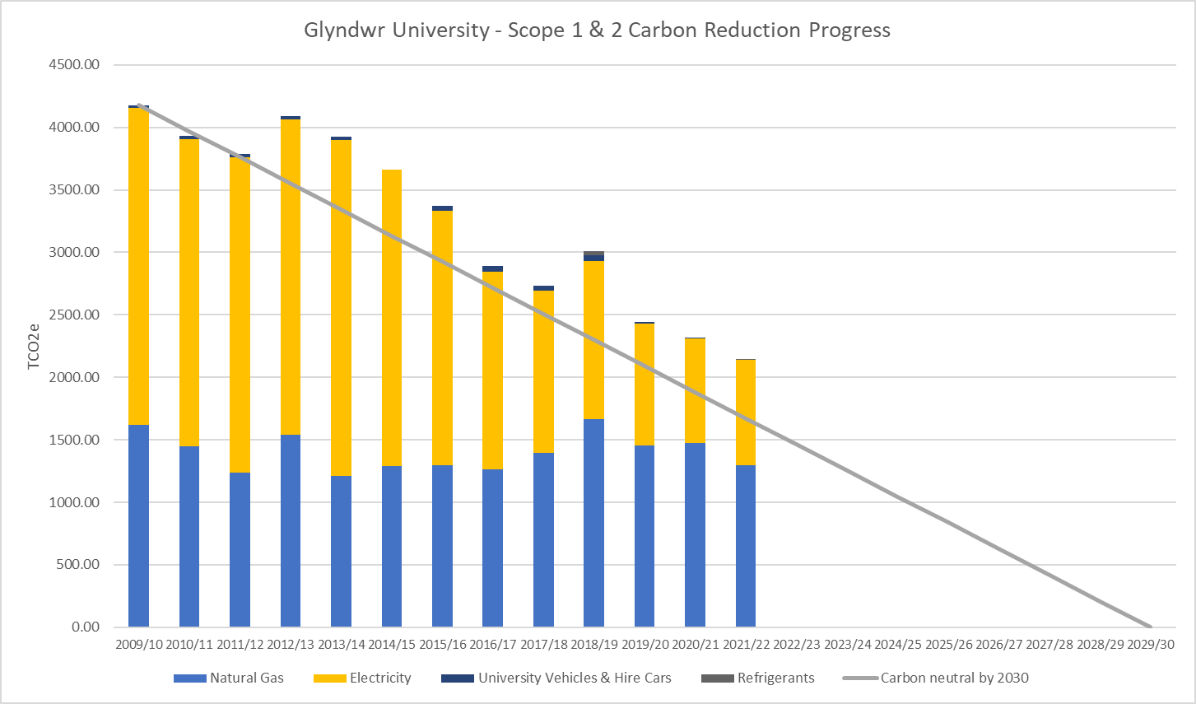

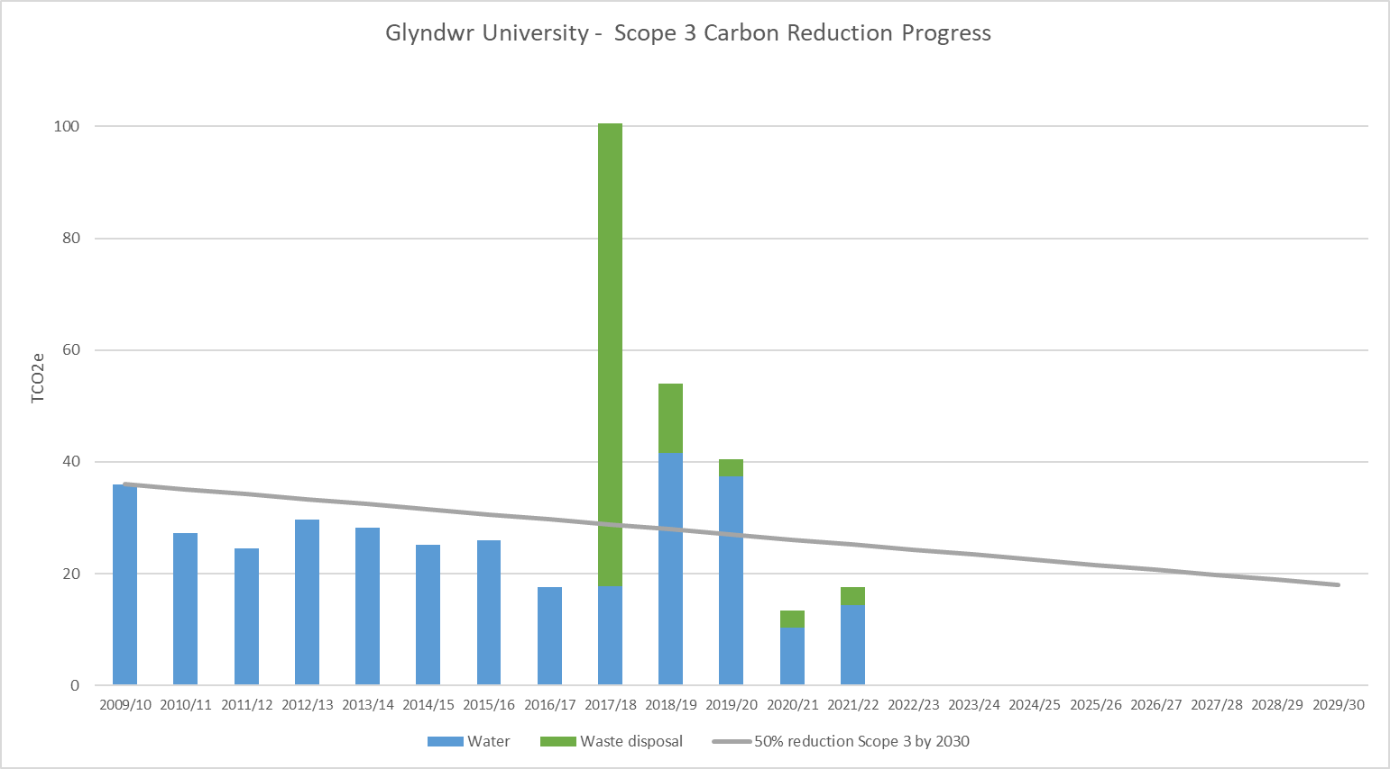

5.5 Carbon Sequestration

The University has open land areas which act as carbon sinks. Most of the open land is in Northop which is home to areas of woodland and grassland. Other areas are on the Wrexham campus.

Figures on the table below are best estimates of land sizes and the emission factor is taken from Welsh Public Sector Reporting Guide.

Location | Land Use | Soil Type | Area | Emission Factor kg/ha | Total Emissions tCO2e
Northop | Mixed broadleaf woodland | Organic | 12 ha | -7.27 | -87.211
Northop | Unimproved grassland | Mineral | 16 ha | -1.44 | -23.051
Wrexham | Grassland | Organic | 3 ha | +0.02 | +0.039
Total |  |  |  |  | -110.224

6 Targets 2022-2025

The University has a target to become carbon neutral for Scope 1 & 2 emissions by 2030 and better understand our Scope 3 by 2026. To achieve the carbon neutral target on this timeline the University aims to reduce Scope 1 & 2 net carbon emissions by 5% annually from a 2009/10 baseline.

Activity | Measures | Targets/ Milestones | Lead/Contributor
Buildings
Improve energy efficiency across all campuses | Undertake an estate condition survey to identify opportunities for energy efficiency projects. Efficiency survey to initially cover Plas Coch Campus followed by other campuses | Plas Coch 2022 | Head of Estates
 | Plan in place for scheduled building improvement works to improve energy efficiency of University buildings | 2023 | Head of Estates
 | Plan in place for scheduled replacement of inefficient equipment for highly efficient plant and equipment | 2023 | Head of Estates/Capital Projects Manager
 | Review metering across all buildings >1000m2 and develop improvement plan as required | 2023 | Head of Estates/SHE Manager
Eliminate gas heating systems | Undertake scoping exercise for low carbon heat projects and renewable heating schemes | 2023 | Head of Estates/Capital Projects Manager
 | A renewable heat strategy will be rolled out | 2026 | Head of Estates
Hard to Decarbonise Buildings | Low carbon transition and delivery plan is developed for hard to decarbonise buildings | 2023 | Head of Estates/Capital Projects Manager
 | Develop firm proposals and business cases are in place for hard to decarbonise building types | 2026 | Head of Estates/Capital Projects Manager
Manage air conditioning systems to replace with air moving and other building modifications to reduce refrigerant usage | All existing units to be reviewed by 2025 and unnecessary or inappropriate units adapted, removed or replaced | 2025 | Contracts & Compliance Manager
New Building standards | New build projects to meet BREAAM “very good” standards and all refurbishment projects >£500k to meet “good” as set out in the Environmental Sustainability Strategy | Ongoing | Capital Projects Manager
 | Develop low carbon and occupational standards for buildings | 2023 | Capital Projects Manager/Head of Estates
Improve water efficiency | Benchmark water usage against other similar institutions and develop water efficiency plan | 2023 | SHE Manager
 | Include water efficiency measures (e.g. grey water/rainwater schemes) as part of any new build project or significant building refurbishment project | On going | Capital Projects Manager
Mobility & Transport
University Fleet & Business Travel | Make EV charging points available for use by staff, students and members of the public accessing campus | 2022 | Head of Estates
 | Transition University owned vehicles to ultra-low emission vehicles by removing fossil fuel vehicles or alternative arrangements to decarbonise the fleet | 2025 | Facilities Manager
 | Continue to encourage the use of University EVs when travelling on University business. Benchmark the work-related journeys made using fossil fuel vehicles | 2023 | Head of Estates
University Travel Plans | Promote opportunities for active travel such as bike hire, cycle purchase scheme for employees, train, bus | Annual | SHE Manager
 | Install electric bike charging points at key locations | 2024 | Head of Estates
 | Work with local authorities and Students Union to develop Active Travel Strategy that will encompass health, wellbeing and sustainability | By 2026 | Facilities Manager
 | Commit to healthier and more sustainable forms of transport by publicly signing a Healthy Travel Charter | By 2026 | Executive Director of Operations
Better Quantify scope 3 activity impacts | Assess emissions from business travel including flights, rail and grey fleet. | 2025 | SHE Manager/ Finance
 | Assess impact of staff and student commuting through annual pulse survey. | 2023 | HR/SHE Manager
Procurement
Improve procurement processes to consider decarbonisation performance as part of the contract award process | We will Identify our category of spend area with high / medium CO2e | By 2023 | Procurement Advisor
 | We will explore how our current contracts can be used to act on CO2e reduction | By 2023 | Procurement Advisor
 | We will review and amend our procurement policies and procedures to promote the reduction of carbon throughout the procurement lifecycle. | By 2023 | Procurement Advisor
 | We will be requiring all bidders to submit a Carbon Reduction Plan on relevant high value tenders to ensure potential suppliers are focused on CO2e reduction | By 2026 | Procurement Advisor
 | Based on the findings from the procurement review determine which other scope 3 emissions should be measured and recorded | 2024 | Executive Director Operations/Head of Estates
Land Use
Offsetting & biodiversity | Calculate status and sequestration potential of land under university ownership | 2023 | Head of Estates
 | University land use is reviewed and plans are in place to improve land use through connection of existing habitats, woodland creation, natural regeneration and habitat restoration to protect biodiversity in line with the biodiversity plan | 2026 | Facilities Manager/ Site Manager Northop
 | Research projects are in place to encourage and stimulate innovative approaches to horticulture/food security sector across the Wales | 2022 | Horticulture Wales
Wellbeing | Connect people with nature by delivering projects on University land around woodland creation and habitat restoration | 2023 | Northop Site Manager
Governance and energy planning
Consider carbon impact or all major institutional decisions | Ensure that initiatives, strategies and major projects are in line with the University’s carbon zero targets and sustainability commitments | Ongoing | VCB
Increase year on year on-site electricity generation | Develop feasibility studies and agree a measurable plan for energy generation targets by 2026-2030 | 2024 | Capital Projects Manager
Develop a clear and achievable plan for fully attaining carbon neutral CO2e by 2030 and significant steps for reducing scope 3 impacts | Optimise space usage across the University through efficient space planning, including office sharing, remote working and adoption of effective digital platforms to support this new way of working. | 2023 | Head of Estates/Capital Projects Manager/Director of IT
Civic Mission
Promotion of carbon reduction through information, education and training | Promote energy and water awareness to encourage staff and students to be more conscious of usage | 2023 | SHE Manager
 | Offer effective education in carbon reduction to the wider community that enable local organisations to meet the net zero challenge | 2025 | FAST/Enterprise

7 Financial Support

As part of the annual budget planning process, financial resources will be reviewed and allocated to ensure that low carbon delivery targets are achieved. Associated costs to implement low carbon activities/projects will be assigned to the appropriate project cost centre.

In addition to University funding, alternative sources of funding will be actively pursued.

Project outputs and carbon reduction achievements from completed projects will be measured and reported as part of the annual environmental sustainability report.

8 Reporting

Carbon reduction performance and progress against the current targets will be monitored and reported at the Quarterly Sustainability Action Working Group Meetings, Chaired by Executive Director of Operations. SAWG will report progress to the SHE Committee, who in turn report to People and Culture Committee.

Carbon reduction and energy performance will be reported in the annual Environmental Sustainability Strategy Report, which will be made publicly available in both English and Welsh. Annual reporting will include:

  - Year on Year progress & previous 3 years carbon emissions
  - Details of projects completed in the reporting year
  - Scope 1&2 emissions per FTE
  - Scope 1&2 emissions per m2
  - Scope 1&2 emissions per gross turnover
  - Scope 1&2 emissions per bedspace
  - Scope 3 – business travel

Specific projects and energy reduction programmes will be reported in line with the objectives set out in the targets set out above. Projects will be prioritised, include a timescale, capital costs, anticipated savings and payback periods and requirements for any additional resources.

The Sustainability pages of the University website will be kept up to date with progress towards achieving carbon neutral.

9 References

- Environmental Sustainability Strategy 2018-2025
- Pathway to decarbonisation by 2030
- Estates and Learning Environment Strategy - Campus 2025
- Estates Annual Report – summarises year on year progress
- HEFCW Carbon Management Policy
- WGU Civic Mission

Definitions from UN IPCC Glossary
For academic year 2017/18 the DEFRA conversion factor for 2018 would be applied for the academic year

