University Logo

|  |  |  |  |
| --- | --- | --- | --- |
| **MANAGEMENT HEADER** | | | |
| Department | Safety, Health and Environment (SHE) | | |
| Author | J Thomas | | |
| Reviewed by | SAWG/SHE Committee | | |
| Authorised by | Executive Director of Operations | | |
| Document Control No. | PLEST2324033 | | |
| Document Replaced | PLEST2223028 | | |
| Version No. | 2 (July 25) | Approval Committee | SLT |
| Date Approved | Via circulation  25.06.24 | Minute No. | TBC |
| Status | Approved | Implementation Date | July 24 |
| Period of Approval | 3 Years | Review Date | July 27 |

|  |
| --- |
| I have carried out an equality impact assessment screening to help safeguard against discrimination and promote equality. P |
| I have considered the impact of the Policy/Strategy/Procedure *(delete as appropriate)* on the Welsh language and Welsh language provision within the University. P |

Low Carbon Transition & Delivery Plan 2022-2026

**for Wrexham University**

# Introduction

The Low Carbon Transition & Delivery Plan outlines the progress made by the University to reduce carbon emissions since 2009/10 baseline year and sets targets for the University to become carbon neutral by 2030 in line with Welsh Government targets for the Public Sector.

The main aim of this plan is to set out how Wrexham University will achieve their Pathway to Carbon Neutral by setting objectives to reduce carbon across the University. The plan will identify which campuses will be considered in scope and the emissions sources that will be considered. The plan forms part of the University Environmental Sustainability Strategy 2018-2025.

# Background

As part of the global effort to tackle climate change, Wrexham University, in line with all public sector employers, seeks to play its part in reducing adverse impacts on the environment by reducing greenhouse gas emissions and promoting positive behaviour both in the University and the wider community.

The University’s Environmental Sustainability Strategy set a target to reduce carbon emissions by 3% year on year by 2020 from the 2009/10 baseline (28.5% carbon reduction). The University significantly exceeded this target and achieved a 45% reduction in scope 1 & 2 carbon emissions in academic year 2020/21 from 2009/10 baseline. (Including Wrexham Village Student Accommodation purchased in 2018)

The Environmental Sustainability Strategy also set a target to achieve a 15% reduction in gas and electricity consumption by 2020. In 2020/21 the University had reduced gas consumption by 8% and electricity consumption by 25% from the 2009/10 baseline. (Including Wrexham Village Student Accommodation purchased in 2018)

Reduction in carbon emissions has been made through energy efficiency projects, installation of energy efficient equipment, installation of photovoltaic solar panels, purchase of renewable electricity, improved energy metering and transforming the University fleet to electric vehicles.

The plan aims to set out the measures that will be taken to meet Welsh Government net zero targets though:

* Improved energy efficiency by carrying out projects to improve the thermal performance of buildings by adopting a “fabric first” approach.
* Improved energy consumption through the installation of low carbon plant and equipment (e.g. LED lighting, insulation, A-rated goods, optimise building controls through an effective building management system) and systems to measure and manage energy more efficiently.
* Explore and invest in low carbon heating projects.
* Explore and develop on-site renewable generation.
* Explore ways in which new developments and major projects can have low embodied carbon and carbon management is built into the project planning.
* Engagement with staff, students and the University community to raise knowledge on climate change and carbon literacy resulting in improved occupant behaviours.
* Engage with the wider community leading by example to support knowledge transfer to support the transition to net zero across Wales.
* Lead and support research supporting decarbonisation of the economy.

# Definitions[1]

**Scope 1 Emissions** Direct emissions from owned or controlled sources (e.g. gas heating, University Vehicles). Wrexham University scope 1 emissions consist of gas, fuel for University owned vehicles & hire cars, fugitive emissions of refrigerant gases from air conditioning systems.

**Scope 2 Emissions** Indirect emissions from the generation of purchased electricity, steam, heating and cooling consumed by the reporting company. Wrexham University scope 2 emissions consist of purchased electricity.

**Scope 3 Emissions** All other indirect emissions that occur in a company's value chain (e.g. water, waste, procurement, transportation). Wrexham University scope 3 emissions currently include water use, waste disposal and recycling. This plan outlines the areas where additional scope 3 measures will be considered by the University.

[Diagram from GHG Protocol](https://www.ghgprotocol.org/sites/default/files/ghgp/standards/Scope3_Calculation_Guidance_0.pdf)

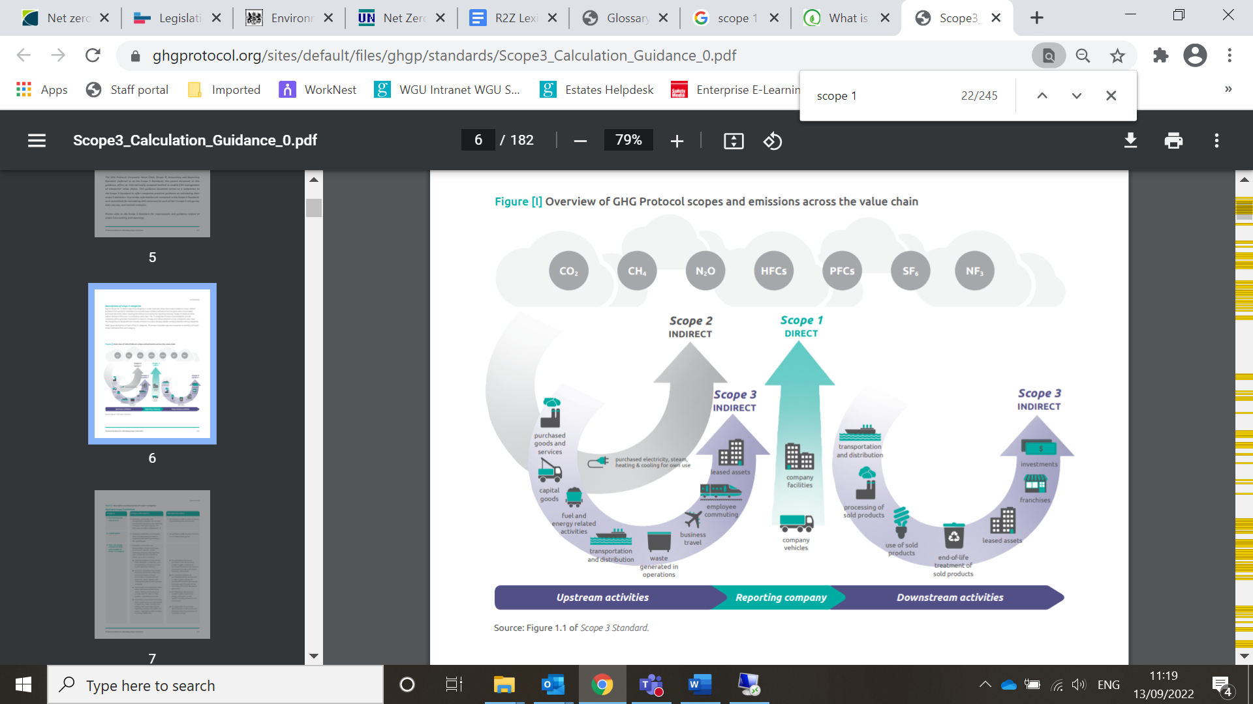

**Net Zero Emissions/Carbon Neutral**

Net zero emissions are achieved when anthropogenic emissions of greenhouse gases to the atmosphere are balanced by anthropogenic removals over a specified period.

**Decarbonisation** The process by which countries, individuals or other entities aim to achieve zero fossil carbon existence. Typically refers to a reduction of the carbon emissions associated with electricity, industry and transport

**Carbon Dioxide Equivalent (CO2e)**

A measure used to compare the emissions from various greenhouse gases based on their global warming potential. For example, the global warming potential for methane over 100 years is 25, therefore 1 tonne of methane released is equivalent to 25 tonnes of CO2 (measured over 100 year time horizon). CO2 therefore works as a single “currency” for greenhouse gases

**Carbon sequestration:** The process of storing carbon in a carbon pool (e.g. soil, ocean or plants, industrial carbon capture process etc)

# Responsibilities

## 4.1 Executive Director of Operations

* Executive responsibility for the Environmental Sustainability Strategy, the Pathway to Carbon Neutral and the Low Carbon Transition and Delivery Plan
* Responsible for Chairing the Sustainability Action Working Group
* Responsible for setting and monitoring objectives and targets to support the achievement of being carbon neutral by 2030.
* Present associated reports and outcomes to VCB and Board of Governors

## 4.2 Head of Estates

* Manage the University Estate and implement appropriate carbon reduction projects to meet the carbon reduction targets.
* Ensure key energy and carbon data is reported to HESA and Welsh Government annually.
* Manage energy procurement process, ensuring that carbon emissions are fundamental to the contract assessment.

## 4.3 Capital Projects Manager

* Ensure new buildings and refurbishments consider sustainable construction principles in the design phase, evaluating the whole-life aspects such as embodied carbon and carbon in-use. Where reasonable and cost effective, to adopt these measures prioritising “fabric first” principles and high levels of air tightness.
* To encourage suppliers and contractors to adopt sustainable practises during the construction phase to reduce the construction impacts which could include emissions from transport of materials, site impacts and biodiversity on site.
* To ensure that the energy requirements of new buildings are provided from renewable and low carbon energy sources wherever possible, either locally or though site wide measures.
* For new build projects, we will seek to achieve Energy Performance Certificate – A rated

## 4.4 Procurement Manager

* Support energy procurement process, ensuring that carbon emissions are fundamental to the contract assessment.
* Ensure that procurement policies include key requirements to consider low carbon solutions.
* Work with suppliers on high value projects to ensure that consideration s given to carbon reduction.

## 4.5 SHE Manager

* Support data collection, verification and reporting to measure progress against the targets in the plan.
* Monitor energy and water usage and provide regular reports to key stakeholders outlining progress towards carbon neutral status.
* Support identification of carbon reduction projects and impact they may have on overall University carbon emissions.

## 4.6 Sustainability Action Forum, Sustainability Clusters & Green Champions

* Monitoring performance against the low carbon transition plan
* Supporting management team to engaging in and promoting sustainable energy efficient behaviours

## 4.7 All Managers

* Responsible for engaging in and promoting sustainable energy efficient behaviours
* To support professional development opportunities that equip staff with the knowledge and skills to support the sustainability commitments of the University.

## 4.8 All Staff, Students, Contractors & Visitors

* Engage with the low carbon transition process by taking ownership in areas of responsibility to implement energy reduction programmes and suggest improvement opportunities

# Emissions Baseline & Carbon Reduction Performance

## 5.1 Calculating Emissions

Carbon emissions are calculated for the academic year - August to July. Campuses included in scope are:

* Plas Coch (including Wrexham Village student accommodation)
* Regent Street
* Northop
* Optic Centre, St Asaph

Exclusions

* Xplore! Science Centre has been excluded from data as they manage their own energy contracts. (Accurate as at Sept 22)
* Scope 3 data for student accommodation that is not managed by the university is not currently included.
* Scope 3 data for waste disposal at Wrexham Village student accommodation

Wrexham University employ Innovative Energy to monitor gas, electricity and water usage via bills and meter readings to report usage and anomalies monthly. Other data such as waste, fugitive refrigerant emissions, University vehicle fuel usage is calculated using sources including supplier data, maintenance reports and finance records etc.

Carbon emissions are calculated using the Defra GHG conversion factors for the relevant fuel source and the relevant year[2]

Since the baseline year there have been several changes to the University Estate as outlined below:

|  |  |  |
| --- | --- | --- |
| **Date** | **Building details** | **Action** |
| Aug 2010 | Plas Coch Hostel accommodation | Closed |
| Mar 2011 | Centre for the Child, Family and Society | Opened |
| Aug 2011 | Racecourse Football Stadium & Colliers Park Training Ground* | Acquired |
| Oct 2011 | Centre for the Creative Industries | Opened |
| Aug 2016 | Racecourse Football Stadium* | Long term lease |
| Aug 2018 | Wrexham Village Student Accommodation | Acquired |
| May 2019 | Colliers Park Training Ground* | Long term lease |
| Jul 2019 | Student Village | Closed |
| Aug 2020 | Corbishley Hall   * Accommodation – closed * Teaching spaces – remain open | Accommodation Closed |
| Oct 2021 | Student Village & Plas Coch Hostel (Northern Quarter) | Sold |
| Jun 2022 | Racecourse Football Ground & Colliers Park Training Ground* | Sold |
| Nov 22 | Ty Dysgu | Acquired |
| Nov 23 | Dean Road | Sold |

*Energy data from Racecourse Football Ground and Colliers Park has not been included in the energy data reported below.

The University will review the data quality periodically via an independent 3rd party.

## 5.2 Scope 1 & 2 Emissions

Scope 1 & 2 emissions have reduced significantly since the baseline year. In Academic Year 2020/21 emissions levels have been influenced by the reduction in site use due to the pandemic.

**Table 1: Carbon Emissions – All University Buildings (including residential accommodation)**

|  |  |  |  |  |  |  |
| --- | --- | --- | --- | --- | --- | --- |
| Year | Scope 1 tCO2e | | | Scope 2 tCO2e | Total Scope  1 & 2 emissions | **Actual Reduction from baseline** |
| Gas | Refrigerant | Fleet | Electricity |
| 2009/10 Baseline | 1621 | No data | 26 | 2532 | 4179 |
| 2010/11 | 1450 | No data | 26 | 2457 | 3934 | -6% |
| 2011/12 | 1238 | No data | 26 | 2520 | 3784 | -10% |
| 2012/13 | 1540 | No data | 26 | 2523 | 4089 | -2% |
| 2013/14 | 1214 | No data | 26 | 2684 | 3924 | -6% |
| 2014/15 | 1288 | No data | No Data | 2371 | 3659 | -12% |
| 2015/16 | 1296 | No data | 41 | 2035 | 3372 | -19% |
| 2016/17 | 1263 | No data | 48 | 1583 | 2894 | -31% |
| 2017/18 | 1396 | 0 | 35 | 1300 | 2731 | -35% |
| 2018/19 | 1503 | 32 | 46 | 1189 | 2769 | -34% |
| 2019/20 | 1284 | 0 | 15 | 896 | 2194 | -47% |
| 2020/21 | 1327 | 0 | 5 | 771 | 2103 | -50% |
| 2021/22 | 1147 | 0.27 | 11.22 | 779 | 1938 | -54% |
| 2022/23 | 1209 | 2.86 | 2.47* | 876 | 2090 | -50% |
| 2023/24 | 1197 | 13.46 | 2.48* | 850 | 2063 | -51% |

‘* Data includes only University owned vehicle fuel use. Previous years included fuel use in hire vehicles – this data is now recorded in the Scope 3 emissions data

In August 2018, the University purchased Wrexham Village student accommodation blocks which have 320 private ensuite bedrooms. Wrexham Village is currently the only accommodation managed by the University.

**Table 2: Carbon Emissions – Residential accommodation only**

|  |  |  |  |  |
| --- | --- | --- | --- | --- |
| Wrexham Village | | | | |
| Year | Scope 1 Emissions tCO2e | Scope 2 emissions tCO2e | Total emissions tCO2e | Actual Scope 1 & 2 Reduction from 2018/19 Baseline |
| 2018/19 | 163 | 75 | 238 |  |
| 2019/20 | 172 | 76 | 248 | 7% increase |
| 2020/21 | 151 | 63 | 213 | 5% decrease |
| 2021/22 | 152 | 64 | 216 | 1% decrease |
| 2022/23 | 169 | 75 | 245 | 10% increase  (Accommodation at full capacity for first time) |
| 2023/24 | 172 | 87 | 258 | 15% increase |

## 5.3 Scope 3 Emissions

Monitoring of Scope 3 emissions from the baseline year has been limited to water supply and discharge. Since 2017/18 waste disposal and recycling has been included in the Scope 3 emissions recorded.

No specific target was set for Scope 3 carbon reduction in the previous Carbon Management Plan. The Environmental Sustainability Strategy set a target to reduce water usage by 15% by 2020 from 2009/10 baseline and the University achieved a 50% reduction in water usage in this time (on original data excluding Wrexham Village). A new target was set to reduce water by 10% by 2025 from the 2019/20 baseline.

The Waste Management Policy sets targets to divert >95% of waste from landfill; Reduce waste disposal by 5% per year (kg/FTE staff/student) based on 2018/19 baseline; To recycle 50% of waste by 2025/26. In 2017/18 87% of waste was landfilled and this has reduced to less than 5% which has significantly reduced scope 3 emissions. In 2021/22 waste per FTE has reduced by 38% from the 2019 baseline.

*Waste Management data does not include data from Wrexham Village student accommodation.

Business Travel including grey fleet, flights and public transport has been estimated for the first time in 2023.

|  |  |  |  |  |  |  |
| --- | --- | --- | --- | --- | --- | --- |
| Year | **Scope 3 tCO2e** | | | | | |
| Water Supply & Discharge | % Carbon Reduction Water | *Waste Management | % Carbon Reduction Waste | Business Travel | % Carbon Reduction Travel |
| 2009/10 Baseline | 36 |  |  |  |  |  |
| 2010/11 | 27 | -24% |  |  |  |  |
| 2011/12 | 25 | -22% |  |  |  |  |
| 2012/13 | 30 | -18% |  |  |  |  |
| 2013/14 | 28 | -21% |  |  |  |  |
| 2014/15 | 25 | -30% |  |  |  |  |
| 2015/16 | 26 | -28% |  |  |  |  |
| 2016/17 | 18 | -51% |  |  |  |  |
| 2017/18 | 18 | -51% | 83 |  |  |  |
| 2018/19 | 31 | -13% | 12 | -85% |  |  |
| 2019/20 | 27 | -25% | 3 | -96% |  |  |
| 2020/21 | 7 | -80% | 3 | -96% |  |  |
| 2021/22 | 10 | -73% | 3 | -96% | 23 |  |
| 2022/23 | 8 | -77% | 3 | -96% | 63* | +170%* |
| 2023/24 | 9 | -75% | 1 | -99% | 209 | +789%* |

* In 2022/23 fuel used in hire vehicles moved from scope 1 to Scope 3 in line with reporting guidance, therefore showing increase in emissions in Scope 3 and reduction in Scope 1. Majority of increase in Business Travel emissions in 2022/23 and 2023/24 due to increase in flights.

|  |  |  |  |  |
| --- | --- | --- | --- | --- |
| Year | **Scope 3 TCO2e - Commuting** | | | |
| Employee & Student Commuting | % Carbon Reduction Staff & Student Commuting | Student Commuting from home to university start of term | % Carbon Reduction Commuting from home |
| 2022/23 | 2049 |  | 6266 |  |
| 2023/24 | 8528 | +316% | 7164 | +14% |

Baseline estimated based on travel questionnaire conducted in March 2023 for staff and analysis of student postcode/country data for students. Significant increase from baseline reflect improved data accuracy.

|  |  |  |
| --- | --- | --- |
| Year | **Scope 3 TCO2e - Procurement** | |
| Procurement of Goods & Services | % Carbon Reduction from Baseline |
| 2018/19 | 4219 |  |
| 2019/20 | 3867 | -8% |
| 2020/21 | 5105 | +21% |
| 2021/22 | 5845 | +39% |
| 2022/23 | 6639 | +57% |
| 2023/24 | 8875 | +110% |

Procurement Data reported includes capital goods including building and refurbishment and is calculated from data provided to UKUPC Consortia.

## 5.4 Progress against Net Zero Target for Scope 1 & 2 emission recorded

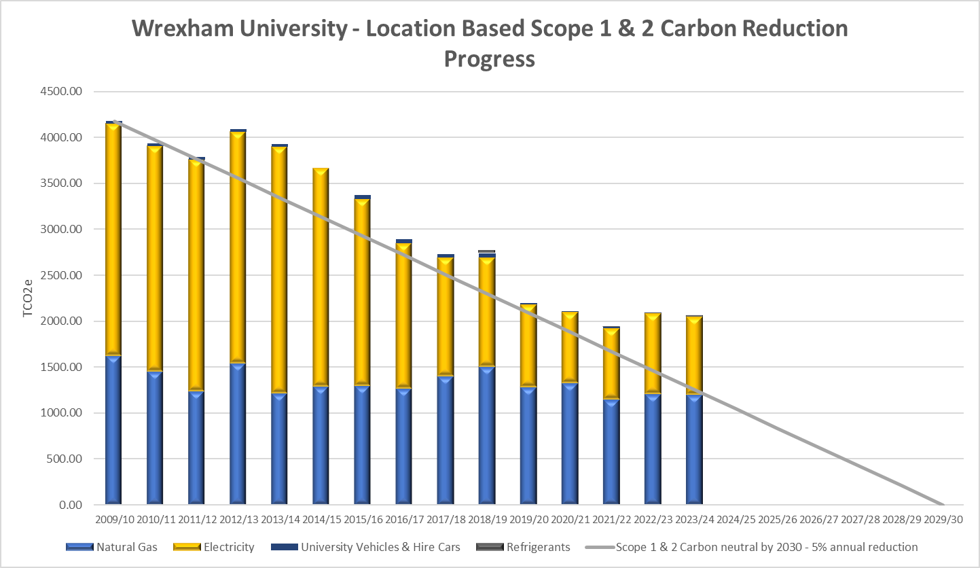

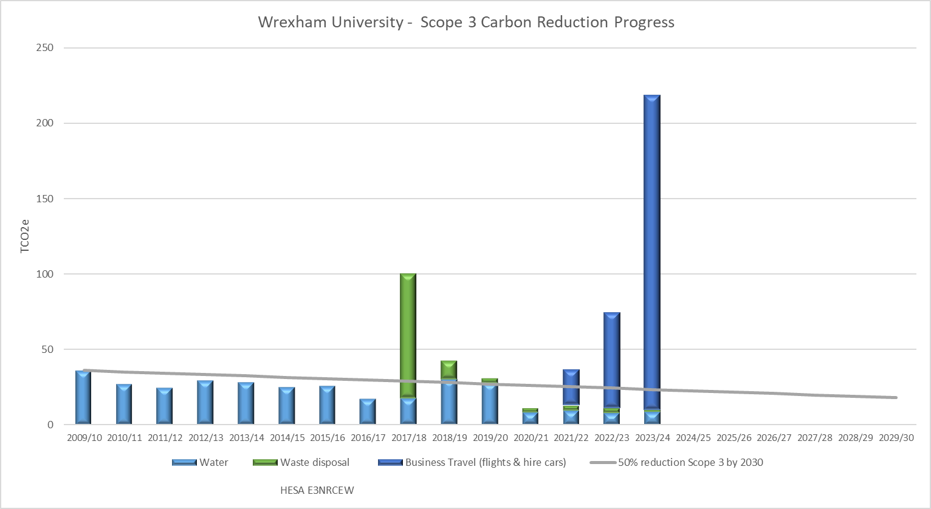

## 5.5 Carbon Sequestration

The University has open land areas which act as carbon sinks. Most of the open land is in Northop which is home to areas of woodland and grassland. Other areas are on the Wrexham campus.

Figures on the table below are best estimates of land sizes and the emission factor is taken from Welsh Public Sector Reporting Guide.

|  |  |  |  |  |  |
| --- | --- | --- | --- | --- | --- |
| Location | Land Use | Soil Type | Area | Emission Factor kg/ha | Total Emissions tCO2e |
| Northop | Mixed broadleaf woodland | Organic | 12 ha | -7.27 | -87.211 |
| Northop | Unimproved grassland | Organic | 16 ha | +0.02 | +0.32 |
| Wrexham | Grassland | Organic | 1 ha | +0.02 | +0.02* |
| Total | | | | | -86.9 |

# Targets 2022-2025

The University has a target to become carbon neutral for Scope 1 & 2 emissions by 2030 and better understand our Scope 3 by 2026. To achieve the carbon neutral target on this timeline the University aims to reduce Scope 1 & 2 net carbon emissions by 5% annually from a 2009/10 baseline.

|  |  |  |  |  |  |
| --- | --- | --- | --- | --- | --- |
| **Activity** | **Measures** | **Targets/ Milestones** | **Lead/ Contributor** | **Activity** | **RAG** |
| Buildings | | | |  |  |
| Improve energy efficiency across all campuses | Undertake an estate condition survey to identify opportunities for energy efficiency projects. Efficiency survey to initially cover Plas Coch Campus followed by other campuses | Plas Coch 2022 | Head of Estates | Fabric of estate condition survey was undertaken by Capita in 2022 for the Plas Coch Buildings. Mechanical equipment was not included as part of this survey. | Completed |
| Plan in place for scheduled building improvement works to improve energy efficiency of University buildings | 2023 | Head of Estates | 2022/23 Review  Project undertaken by Heat Network Delivery Unit conducted a techno-econonic feasibility study to assess the University heat network and recommend future improvements.  Custom Solar produced a plan which identifies the scope for PV generation on the main campus.  2023/24 Review  Feasibility study for geothermal heat supply completed and assessment of proposals ongoing |  |
| Plan in place for scheduled replacement of inefficient equipment for highly efficient plant and equipment | 2023 | Head of Estates/ Capital Projects Manager | 2022/23 Review  To date no formal assessment has been made of inefficient equipment to develop and scheduled replacement plan.  Further assessment of the impact of installation low energy saving measures to be made.  2023/24 Review  Assessment of current boiler systems at Plas Coch in progress to assess options for repair or replacement in line with the low carbon heat solution. |  |
| Review metering across all buildings >1000m2 and develop improvement plan as required | 2023 | Head of Estates/SHE Manager | 2022/23 Review  Work is ongoing with Elcomponent to reinstate the full operation of the electronic submetering data capture where some of the connections have failed and software has become obsolete  2023/24 Review  Central control unit is being upgraded at Wrexham due for completion end 2024 and metering will be linked to this system. Central control system upgraded at Crispin Lane as part of the refurbishment plans completed early 2024. |  |
| Eliminate gas heating systems | Undertake scoping exercise for low carbon heat projects and renewable heating schemes | 2023 | Head of Estates/ Capital Projects Manager | 2022/23 Review  Technoeconomic feasibility study for low carbon heat network is being undertaken to cover the main Wrexham Campus (excluding Wrexham Village and new buildings). Study has been funded by Heat Network Delivery Unit (HNDU)  2023/4 Review  Feasibility study for geothermal heat supply completed and assessment of proposals ongoing |  |
| A renewable heat strategy will be rolled out | 2026 | Head of Estates | To follow from the low carbon heat scoping exercise |  |
| Hard to Decarbonise Buildings | Low carbon transition and delivery plan is developed for hard to decarbonise buildings | 2023 | Head of Estates/ Capital Projects Manager | 2022/3 Review  Further support is required for this work to understand achievable goals and costs of implementing required improvements.  2023/24 Review  Review of the low carbon heat solutions are being assessed. The decision on the option adopted will influence whether specific plans are required for hard to decarbonise buildings (e.g. may not be required if geothermal heat is adopted) |  |
| Develop firm proposals and business cases are in place for hard to decarbonise building types | 2026 | Head of Estates/ Capital Projects Manager | To follow from low carbon heat decision |  |
| Manage air conditioning systems to replace with air moving and other building modifications to reduce refrigerant usage | All existing units to be reviewed by 2025 and unnecessary or inappropriate units adapted, removed or replaced | 2025 | Contracts & Compliance Manager | 2022/23 Review  Clover Technical Services, the University heating and refrigeration contractors, are compiling a full asset list of air conditioning equipment currently installed.  2023/24 Review  High efficiency air source heat pumps and heat recovery ventilation systems have been installed in new refurbished areas. No new air condition will be installed in these areas.  EEOC new build will have chillers installed for operational processes (e.g. microwave research activity etc), not for thermal comfort.  High efficiency glass has been specified on all new building to reduce heat gain and overheating assessments were completed as part of the design phase. |  |
| New Building standards | **Energy Efficiency**  Target: Achieve an energy performance certificate (EPC) rating of A for all new buildings.  Objective: Integrate above minimum levels of insulation, energy-efficient windows, and high-efficiency HVAC systems to minimise energy consumption. These should include heat recovery units and heat pump technology. | Ongoing | Capital Projects Manager | 2023/24 Review  New targets set in this area to remove references to BREAAM which does not strongly include carbon reduction measures.  Construction work on EEOC started in Feb 2024 |  |
| **Renewable Energy Integration**  Target: Generate a proportion of the building's energy requirements on-site through renewable sources to enable an EPC rating of A  Objective: Install photovoltaic solar panels on rooftops and other suitable surfaces. | Construction work on EEOC started in Feb 2024 |
| **Water Efficiency**  Target: Reduce potable water usage compared to conventional buildings.  Objective: Install low-flow appliances and consider water management in landscaping schemes. | Construction work on EEOC started in Feb 2024 |
| **Sustainable Materials**  Target: Ensure that at least 40% of construction materials are sourced from sustainable, recycled, or local sources.  Objective: Prioritise the use of materials with low embodied carbon, such as recycled steel and sustainably sourced timber wherever possible. | Construction work on EEOC started in Feb 2024 |
| **Waste Reduction**  Target: Divert at least 90% of construction waste from landfills.  Objective: Implement a comprehensive construction waste management plan. | Construction work on EEOC started in Feb 2024 |
| **Biodiversity Enhancement**  Target: Achieve a net gain in biodiversity for each project or the campus as a whole.  Objective: Incorporate suitable plant species in landscaping to enhance local biodiversity. | Construction work on EEOC started in Feb 2024 |
| **Indoor Environmental Quality**  Target: Maintain optimal indoor air quality and natural lighting levels.  Objective: Use advanced ventilation systems to ensure fresh air circulation.  Objective: Design buildings to maximise natural light penetration while minimising glare. | Construction work on EEOC started in Feb 2024 |
| Develop low carbon and occupational standards for buildings | 2023 | Capital Projects Manager/ Head of Estates | 2023 Review  Support from Local Authority and feedback from consultation work above required to set standards for refurbished buildings.  Targets for new buildings will be set as outlined above  2024 Review  No further action in 2023/24 |  |
| Improve water efficiency | Benchmark water usage against other similar institutions and develop water efficiency plan | 2023 | SHE Manager | 2022/3 Review  Water usage is monitored on a monthly basis and can be benchmarked against data supplied via HESA. Work to benchmark is required.  Project to be undertaken to assess the impact of installing point source water heaters and eliminating circulating hot water.  2023/4 Review  Benchmark against 7 other Universities in Wales/local (LJMU, Chester) found that Wrexham were 5th when for m3 water per full time equivalent student. 2.62m3/FTE compared to 35.47m3/FTE at Aberystwyth (highest) and 1.82/FTE at Staffordshire (lowest). Wrexham were 7th when benchmarking m3/Gross Internal Area of Buildings. 0.24m3/m3GIA compared to 1.29 Aberystwyth (highest), 0.21m3/m3 GIA Chester (lowest)  Water efficiency measures are continually implemented as part of the on-going campus refurbishment plans |  |
| Reduce total water consumption (m3) by 10% on a 2019/20 baseline | 2025 | Capital Projects Manager/ Head of Estates | In 2023 an 11% reduction against 2019/20 baseline was achieved  In 2024 an 18% reduction against 2019/20 baseline was achieved |  |
| Include water efficiency measures (e.g. grey water/rainwater schemes) as part of any new build project or significant building refurbishment project | On going | Capital Projects Manager | 2023/24 Review  Low water usage appliances have been installed throughout all new refurbishments and have been specified for all new build projects |  |
| Mobility & Transport | | | |  |  |
| University Fleet & Business Travel | Make EV charging points available for use by staff, students and members of the public accessing campus | 2022 | Head of Estates | 2022/23 review  EV charging points have been installed on all campuses and are available for staff, students and members of the public to use. Policy is in place outlining the use of public charging points and usage can be monitored via the AmpEV app. | Complete |
| Transition University owned vehicles to ultra-low emission vehicles by removing fossil fuel vehicles or alternative arrangements to decarbonise the fleet | 2025 | Estates and Campus Management Support Officer | 2022/3 Review  Most University fleet vehicles are fully electric with on 3 remaining fossil fuel fleet vehicles. 1 further electric utility vehicle is currently being purchased for use by the Sports Centre  In addition, the University owned vehicles an Enterprise club car is being sourced which is hybrid and can be used for longer journeys  2024 Review  Additional EV chargers installed at CIB at Wrexham |  |
| Continue to encourage the use of University EVs when travelling on University business. Benchmark the work-related journeys made using fossil fuel vehicles | 2023 | Head of Estates | 2023 Review  There is good uptake in use of the University Electric Vehicles.  Data was reported to HESA estimating the work-related journeys made using fossil fuel vehicles via information from the expenses system (including grey fleet, taxis, trains, flights) |  |
| University Travel Plans | Promote opportunities for active travel such as bike hire, cycle purchase scheme for employees, train, bus | Annual | SHE Manager | 2022/23 Review  As part of Go Green Week 27th Feb several events were held to promote active travel including promoting cycle hire from the Sports Centre, Active Travel and Commuting questionnaire, Competition for active commuters, publicising public transport availability and local attractions at Wrexham Village  2023/24 Review  Active travel options were communicated to staff and students at the start of term and throughout semester 1. Options for alternative travel arrangements were promoted for graduation in May 24. |  |
| Work with local authorities and Students Union to develop Active Travel Strategy that will encompass health, wellbeing and sustainability | By 2026 | Head of Estates | 2022/3 review  This activity will link with the campus improvement plan and WCBC active travel plan. WU are working closely with WCBC on the Northern Gateway project which is closely linked with Active travel plan  A framework travel plan will also form part of the planning requirements for the University’s construction plans  2023/24 Review  No further joint working activity has taken place with WCBC in relation to their active travel plan during the academic year. Contact on the project will be maintained. |  |
| Commit to healthier and more sustainable forms of transport by publicly signing a Healthy Travel Charter | By 2026 | Executive Director of Operations | 2023/24 Review  Activity will be linked to the University Mental Health and Wellbeing Committee in 2024/25 |  |
| Better Quantify scope 3 activity impacts | Assess emissions from business travel including flights, rail and grey fleet. | 2025 | SHE Manager/ Finance | 2022/23 Review  Emissions from University travel have been calculated for 2021/22 based on the records available via finance. Improvements in accuracy in future can be made if all destinations are captured in the order description.  2023/24 Review  Sustainable Travel Policy has been developed to ensure that staff and students take the most climate conscious travel decision for business travel | Complete |
| Assess impact of staff and student commuting through annual pulse survey. | 2023 | HR/SHE Manager | 2022/23 Review  Active travel and commuting survey took place during March 2022. Survey results are to be analysed and emissions calculated. Several activities to improve active travel have been raised from the questionnaire that can be acted on (e.g. better bike storage)  2023/24 Review  Survey results were used to estimate routine staff commuting carbon emissions. Student postcode/country analysis to estimate daily commuting Scope 3 emissions and the emissions associated with travelling from home to University at the start and end of term |  |
| Procurement | | | |  |  |
| Improve procurement processes to consider decarbonisation performance as part of the contract award process | We will Identify our category of spend area with high / medium CO2e | By 2023 | Procurement Advisor | The University on an annual basis provides our total influenceable procurement spend data to the North West Universities Procurement Consortium (NWUPC) who then utilises the Hunter Spend Analysis tool to provide a Scope 3 report on C02e for all categories of spend and on individual suppliers. The Spend Analysis tool also provides Scope 1 & 2 emissions figures associated with Business Travel and supply of gas and electricity. The Scope 3 report identifies our high and medium CO2e category areas and by individual suppliers. |  |
| We will explore how our current contracts can be used to act on CO2e reduction | By 2023 | Procurement Advisor | As a University we subscribe to the Net Positives Futures Supplier Engagement Tool (HE), which provides our suppliers with a free sustainability action plan. As part of their plan’s suppliers answer questions around their carbon commitments and are presented with carbon reduction actions to work towards. |  |
| We will review and amend our procurement policies and procedures to promote the reduction of carbon throughout the procurement lifecycle. | By 2023 | Procurement Advisor | Through the use of Net Positives Futures Supplier Engagement Tool (HE), we encourage and promote suppliers to register with the Supplier Engagement Tool, and individual suppliers are required annually to report upon and monitor against the following criteria:   * Have you made a public commitment to respond to the climate and ecological emergency? * Has your organisation confirmed a Net Zero Target? * Have you developed a carbon reduction plan? * Have you set public emission reduction targets for Scopes 1 and 2? * Have you set public emission reduction targets for Scope 3? * Do you have a system in place to monitor and report on your carbon reduction activity? * Do you take into account sustainability and carbon emissions when selecting suppliers? * Have you undertaken a waste audit? * Do you have a waste reduction plan? * Do you have a plan for the elimination of single-use plastic from your operations? * Do you have REGO certification for all remaining grid electricity? |  |
| We will be requiring all bidders to submit a Carbon Reduction Plan on relevant high value tenders to ensure potential suppliers are focused on CO2e reduction | By 2026 | Procurement Advisor | The University when procuring the recent high value tender for the New EEOC Building, at Plas Coch campus which had a contract value of £8.5m which was funded as part of the North Wales Growth Deal. During the Design & Construction phases a 40%reduction in embodied carbon in the build has been achieved and we are working towards net zero in operational target which currently is 60% compliance.  The requirement for Carbon Reduction Plans is already included in our Tenders for projects above £5m in value as per the Welsh Procurement Policy Note (WPPN 06/21). |  |
| Based on the findings from the procurement review determine which scope 3 emissions should be measured and recorded | 2024 | Executive Director Operations/ Head of Estates | To be completed in the first part of academic year 2024/25 |  |
| Land Use | | | |  |  |
| Offsetting & biodiversity | Calculate status and sequestration potential of land under university ownership | 2023 | Head of Estates | 2023/24 Review  Current land sequestration has been calculated and currently a total of 110.224 tCO2e are sequestered. | Complete |
| University land use is reviewed and plans are in place to improve land use through connection of existing habitats, woodland creation, natural regeneration and habitat restoration to protect biodiversity in line with the biodiversity plan | 2026 | Site Services Supervisor Northop | 2022/3 Review  WU have an active biodiversity plan in place and is working to improve habitats. Further work is required to understand scope for further sequestration and biodiversity net gain across all campuses.  2023/24 Review  Biodiversity Enhancement Plan has been reviewed 2023/24 and outlines the activities that have happened to improve biodiversity across all campuses.  As part of the EEOC new build a Biodiversity net gain plan has been agreed and land improvements including tree planting and wildflower meadow planting will take place at Northop campus |  |
| Research projects are in place to encourage and stimulate innovative approaches to horticulture/food security sector across the Wales | 2022 | Horticulture Wales | 2022/23 Review  Horticulture Wales project is ongoing to mid-2023 when results of the project will be communicated.  2023/24 Review  The Horticulture Wales project has been extended until end of December 2024. Focus has been on outreach to local growers, horticulture projects and community and schools’ groups coupled with hydroponic growing projects demonstrating the feasibility of growing using these techniques. Plants and microgreens grown as part of the project have been sold or donated across University Campuses and to the wider community. |  |
| Wellbeing | Connect people with nature by delivering projects on University land around woodland creation and habitat restoration | 2023 | Site Services Supervisor/ Xplore! Nature/ Student Support Navigators | 2022/3 Review  WU are involved with several projects connecting people and nature including:   * Nature Based Social Prescribing project which has received funding. * Xplore! Outdoors has been set up and provides woodland school activities from the Northop campus. * Work with Amphibian and Reptile Conservation Trust to develop and improve ponds on the Northop campus with volunteers. * Horticulture Wales projects which work with local businesses and groups to engage people with growing. * Activities such as tree planting, outdoor yoga and meditation etc as part of University events such as Go Green Week and Wellbeing week. |  |
| Governance and energy planning | | | |  |  |
| Consider carbon impact on all major institutional decisions | Ensure that initiatives, strategies and major projects give consideration to the University’s carbon zero targets and sustainability commitments | Ongoing | VCB | 2022/23 Review  Further activity is required to provide suitable training and communication to SLT on the net zero plan and how this dovetails with all strategies and projects  2023/4 Review  Major capital projects boards consider carbon management. Policies and procedures are reviewed by SLT. |  |
| Increase year on year on-site electricity generation | Develop feasibility studies and agree a measurable plan for energy generation targets by 2026-2030 | 2024 | Capital Projects Manager | 2022/23 Review  Custom Solar have produced a plan which identifies the scope for PV generation on the main campus  2023/24 Review  In 2024 new PV panels are being installed on Xplore! Science Discovery Centre to be completed August 2024. PV panels will be installed on new build EEOC due for completion autumn 2025 and PV has been included on the plans for HEIQ phase 2b to start construction 2025 |  |
| Develop a clear and achievable plan for fully attaining carbon neutral CO2e by 2030 and significant steps for reducing scope 3 impacts | Optimise space usage across the University through efficient space planning, including office sharing, remote working and adoption of effective digital platforms to support this new way of working. | 2023 | Head of Estates/ Capital Projects Manager/ Director of IT | 2022/23 Review  On going projects in progress to develop more blended working spaces, monitoring usage of spaces, active review of building opening hours and improvements to building Wi-Fi and data connectivity.  2023/24 Review  A detailed space utilisation has been completed in 2024 to understand classroom usage. A new Space and Planning Management (SPAM) committee was set up this academic year to ensure better space utilisation. Timetabling Policy has been approved to ensure that best usage is made of available spaces.  The blended working space in the Alive Hub is being expanded over Summer 2024 and bringing the ground floor of the current space into full usage as a staff working space.  A major project to improve connectivity and Wi-Fi reliability is taking place over summer 2024 to ensure that digital platforms are accessible and there is less downtime due to poor connectivity.  Additional meeting rooms are being upgraded to provide capacity for blended meetings. |  |
| Civic Mission | | | |  |  |
| Promotion of carbon reduction through information, education and training | Promote energy and water awareness to encourage staff and students to be more conscious of usage | 2023 | SHE Manager | 2022/23 Review  Energy information was shared at Go Green Week  2023/24 Review  Ongoing promotion of the short courses available free of charge to staff and students on climate change.  Carbon transition and Delivery Plan and pathway to Carbon neutral by 2030 available on the University website which outlies the current energy status of the university. |  |
| Offer effective education in carbon reduction to the wider community that enable local organisations to meet the net zero challenge | 2025 | FACE/ Enterprise | 2023/24 Review  Sustainability in Business and Introduction to Climate Change are available as short courses (free to staff and students)  Carbon literacy skills programme to be developed for key personnel at all levels of the business |  |

# Financial Support

As part of the annual budget planning process, financial resources will be reviewed and allocated to ensure that low carbon delivery targets are achieved. Associated costs to implement low carbon activities/projects will be assigned to the appropriate project cost centre.

In addition to University funding, alternative sources of funding will be actively pursued.

Project outputs and carbon reduction achievements from completed projects will be measured and reported as part of the annual environmental sustainability report.

# Reporting

Carbon reduction performance and progress against the current targets will be monitored and reported at the Quarterly Sustainability Action Working Group Meetings, Chaired by Executive Director of Operations. SAWG will report progress to the SHE Committee, who in turn report to People and Culture Committee.

Carbon reduction and energy performance will be reported in the annual Environmental Sustainability Strategy Report, which will be made publicly available in both English and Welsh. Annual reporting will include:

* + Year on Year progress & previous 3 years carbon emissions
  + Details of projects completed in the reporting year
  + Scope 1&2 emissions per FTE
  + Scope 1&2 emissions per m2
  + Scope 1&2 emissions per gross turnover
  + Scope 1&2 emissions per bedspace
  + Scope 3 – business travel

Specific projects and energy reduction programmes will be reported in line with the objectives set out in the targets set out above. Projects will be prioritised, include a timescale, capital costs, anticipated savings and payback periods and requirements for any additional resources.

The Sustainability pages of the University website will be kept up to date with progress towards achieving carbon neutral.

# References

* [Environmental Sustainability Strategy 2018-2025](https://glyndwr.ac.uk/sustainability/policies-and-documents/)
* [Pathway to decarbonisation by 2030](https://glyndwr.ac.uk/sustainability/policies-and-documents/)
* [Estates and Learning Environment Strategy - Campus 2025](https://issuu.com/glyndwruni2020/docs/wgu_estates_and_learning_environment_strategy_camp)
* [Estates Annual Report – summarises year on year progress](https://glyndwr.ac.uk/sustainability/policies-and-documents/)
* [HEFCW Carbon Management Policy](https://www.hefcw.ac.uk/wp-content/uploads/2020/12/W13-38HE-Carbon-Management-Policy.pdf)
* [WU Civic Mission](https://glyndwr.ac.uk/about/civic-mission/)

1. [Definitions from UN IPCC Glossary](https://www.ipcc.ch/sr15/chapter/glossary/#:~:text=The%20zero%20emissions%20commitment%20is,setting%20anthropogenic%20emissions%20to%20zero.&text=The%20infrastructure%20commitment%20is%20the,end%20of%20its%20expected%20lifetime.)
2. For academic year 2017/18 the DEFRA conversion factor for 2018 would be applied for the academic year