

|  |  |  |  |  |
| --- | --- | --- | --- | --- |
| **WASTE MANAGEMENT POLICY** | | | | |
| **Department** | Safety, Health and Environment | | | |
| **Author** | Jenny Thomas | | | |
| **Authorised By:** | Executive Director of Operations | | | |
| **Implementation By:** | Sustainability Action Working Group | | | |
| **Policy Reference:** | TBC | | | |
| **Policy Replaced:** | POSHE1920069 | | | |
| **Version No:** | VXXX | **Approval Committee:** | VCB | |
| **Date approved:** |  | **Minute no:** |  | |
| **Status:** | Draft | **Implementation Date:** | XXXX | |
| **Period of approval:** | 3 years | **Review Date:** | XXXX | |
| I have carried out an equality impact assessment screening to help safeguard against discrimination and promote equality. | | | | x |
| I have considered the impact of the Policy/Strategy/Procedure *(delete as appropriate)* on the Welsh language and Welsh language provision within the University. | | | | x |

1. **Purpose**

This policy sets the arrangements for implementing and maintaining an effective Waste Management programme at the University. The Waste Management programme aims to reduce environmental impacts and costs through improved resource management, while meeting legal obligations.

The policy sets out a framework for University staff, students and other stakeholders to reduce the amount of waste produced, segregate reusable and recyclable waste and minimise waste that is disposed of by landfill or incineration.

1. **Scope**

The policy applies to all University Campuses.

1. **Waste Management Principles**
   1. **Legal Compliance**

The University will ensure that waste is segregated, stored, collected and disposed of in line with regulatory requirements. Wales is aiming to be the world’s best recycling nation and the Environment (Wales) Act 2016 sets specific requirements to:

* Segregate waste streams to ensure uncontaminated recyclables can be collected
* Restrict waste to energy disposal routes to ensure that maximum material recycling
* Advocate separate food waste collection
  1. **Waste Hierarchy**

The waste management hierarchy is the guiding principle for how waste is managed at the University, setting out the order in which waste management measures should be prioritised based on environmental impact to drive towards zero waste.

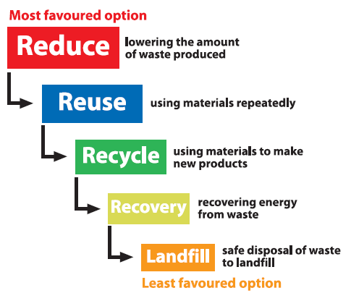

* 1. **Waste as a resource**

Waste streams produced by the University may have a market value if collected and segregated properly. The University will seek to consider waste as a resource and raise revenue wherever possible or identify opportunities for disposing of material free of charge.

Waste will be minimised by integrating the principles of the circular economy into decision making to promote the reuse of materials and equipment where possible.

The University will support research which is actively investigating the reduction of waste though new and innovative solutions.

1. **Waste Management Performance**

An accurate monitoring of waste streams for non-residential waste has allowed the University to reduce the volume of waste generated and increase recycling rates. Improvements in recycling have been made through increasing waste streams segregated for recycling (including food waste), removing desk side waste bins and ongoing promotion of correct disposal routes. The graphs below outline performance since 2017/18 (Waste from residential accommodation not included in data).

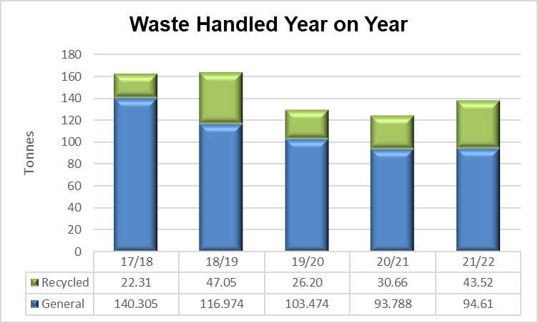 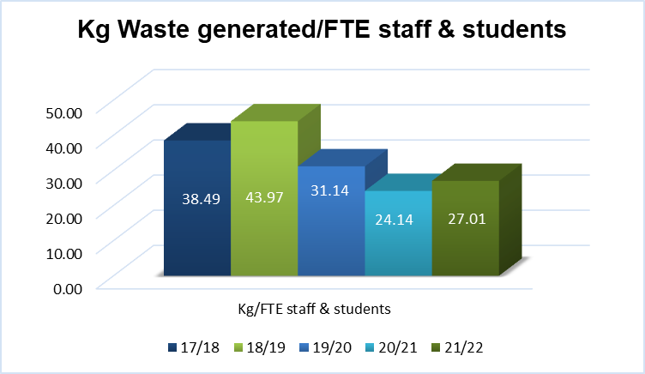

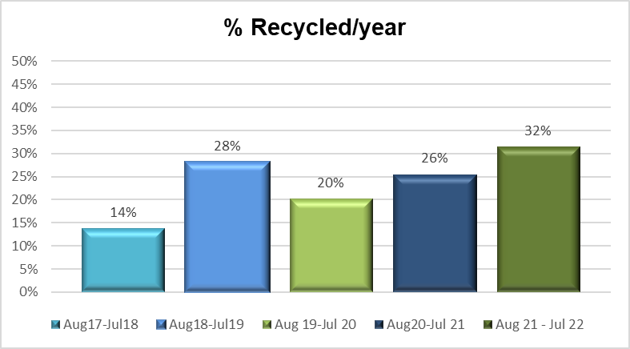 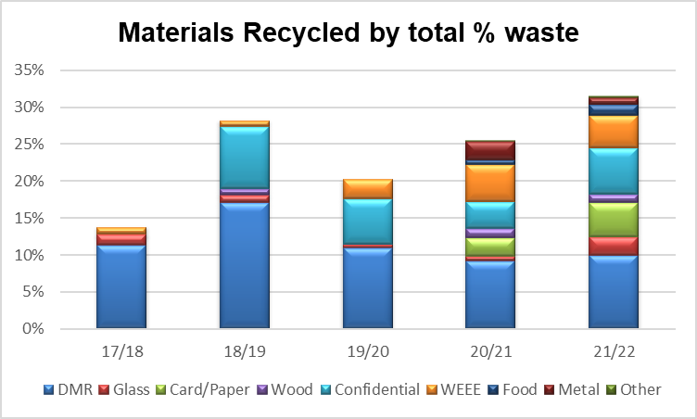

1. **Waste Management Objectives & Targets 2023-2026**

|  |  |  |
| --- | --- | --- |
| **Objective** | **Target** | **Goals** |
| To reduce the total amount of waste generated each year | Reduce waste disposal by 5% per year (kg/FTE staff/student) based on 2018/19 baseline | * Promote existing reuse schemes (e.g. keep cups) and develop new reuse schemes * Establish relationships with charities/ reuse organisations to re-use/re-purpose equipment or materials where possible (e.g. furniture) * Review how circular economy principles are integrated into decision making processes |
| Increase the proportion of waste recycled | To recycle 50% of waste by 2025/26 | * In addition to the collection of food waste from catering outlets, provide food recycling provision in key areas across the campuses by April 2024 * In line with Environment Act (Wales) 2016, move from Dry Mixed Recyclable waste collection to 2 separate waste streams for Paper & Card and Plastic & Tins by April 2024 * Conduct annual waste audit to determine recycling levels in each area and target areas for improvement * Communicate to staff and students about what they can recycle and how to segregate their waste |
| Zero waste sent to landfill | Maintaining >95% waste diverted from Landfill | * Consider resource use and include recycling infrastructure in construction and refurbishment projects * Monitor diversion rates reported by the waste contractor and investigate when landfill is indicated * Calculate carbon emissions from waste disposal and include in Scope 3 carbon emission calculations |

1. **Waste Streams**
   1. **Dry Mixed Recyclables**

Dry mixed recyclables (DMR) collection is a co-mingled waste collection which will be sorted for recycling by the waste management contractor. The following waste materials can be put in the DMR bins:

* Paper
* Card
* Plastic bottles & caps
* Cans & Tins

Following the implementation legislation enabling the Environment Act (Wales) 2016[1], Dry Mixed Recycling will no longer be an acceptable collection method and the following wastes must be segregated for separate collections:

* Food Waste
* Paper & Card
* Glass
* Metal, plastic, and cartons and other fibre-plastic composite packaging of a similar composition
* Waste Electrical and Electronic Equipment
  1. **Hazardous Waste**

Hazardous waste includes but is not limited to:

* Chemicals
* Solvents
* Oils (except edible oil)
* Batteries
* Asbestos
* Equipment containing ozone depleting substances
* Fluorescent tubes and other mercury containing waste
* Hazardous waste containers and other materials contaminated with hazardous waste (e.g. used spill kits)
* Persistent Organic Pollutants (e.g. foam filled furniture treated with fire retardant)

Hazardous waste must be kept separate from other waste streams as it has more rigorous regulatory and disposal controls. If you are unsure whether your waste materials are classed as hazardous, please keep them separate and contact SHE Manager. (healthandsafety@glyndwr.ac.uk)

Hazardous waste must be stored in sealed, labelled containers that are suitable for the substance. Collection will be dealt with per waste consignment. If the same type and quantity of hazardous waste is generated on a regular basis a contract may be set up for regular collection.

* 1. **Waste Electrical and Electronic Equipment Waste**

Waste Electrical and Electronic Equipment (WEEE) Waste includes all types of electrical and electronic devices (e.g. TVs, computers, light bulbs, toner cartridges, fridges, phones, radios, toasters, kettles, washing machines etc.)

WEEE waste must be segregated and collected separately for re-use/recycling. Computer/IT waste will be managed by IT and other WEEE waste will be collected in the waste compound and collected periodically.

* 1. **Confidential Waste**

Confidential waste is any material that contains personal information that can be used to identify individuals including their name, address, financial data, etc. Confidential waste is securely shredded and recycled. Confidential waste bins are located around the University or, a collection bag and security seal tag may be obtained from Estates and Campus Management.

* 1. **Other Waste Streams**

Other waste streams separately collected at Wrexham University include

* + - Wood – including pallets, furniture etc
    - Metal
    - Glass
  1. **Clinical Waste**

Clinical waste is waste produced from healthcare and similar activities that may pose a risk of infection (e.g. swabs, bandages etc). Separate collection methods are in place for this material. If you require additional clinical waste bins or require a new collection, contact Estates.

1. **Responsibilities**

|  |  |
| --- | --- |
| **Area** | **Responsibilities** |
| All Staff/Students | * Segregate waste into recyclable and non-recyclable waste streams as far as possible * Segregate the following materials for separate disposal:   + Waste Electrical & Electronic Equipment   + Batteries   + Plasterboard   + Hazardous Waste * Request changes to waste collection to SHE Manager (e.g. additional recycling bins, change to bin collection frequency) * Use only approved waste contractors. Waste management is heavily regulated, and operators must be licenced and approved. Please contact SHE Manager if you want to use a new waste contractor |
| SHE Manager | * Provide and manage waste collection services for main waste streams including: * General * Segregated recyclables (glass, paper, card, metal, plastics, wood etc.) * Confidential Waste * Food * WEEE * Ensure that companies used for routine waste collection are licenced and approved operators * Maintain copies of waste transfer notes for a period of at least 2 years and hazardous waste consignment notes for 3 years * Monitor performance of the waste contractors and record information about the waste generated on site * Maintain University hazardous waste producer registration * Where appropriate, provide additional recycling facilities for large events planned on campus |
| IT (WEEE waste) | * Store IT waste electrical and electronic waste ready for secure disposal by a licenced waste contractor * Ensure that waste operator is licenced and authorised * Maintain waste transfer notes of collections for a period of at least 3 years |
| Producers of non-routine waste (including hazardous waste) | * Ensure that only approved waste contractors are used (please liaise with SHE Manager to set up new contractors to ensure correct licences are in place) * Inform SHE Manager of waste collected to enable accurate waste monitoring * Maintain consignment notes (hazardous waste) for a period of at least 3 years and waste transfer notes (non-hazardous waste) for a period of at least 2 years |
| Contractors | * Provide Risk Assessment and Method Statement for contracted work and agree with Wrexham University Site contact how waste will be managed |
| Tenants | * Comply with the waste management principles set out in Section 3 |

1. **Communication**

Effective communication is fundamental to a successful waste management programme. Communication tools used will include:

* Updating WGYou to provide policy and performance information
* Communicating achievements and updates via Campus Talk
* Engaging with new staff and students about waste and recycling facilities
* Engaging with staff and students via social media and with the assistance of University Green Champions
* Responding to questions and feedback from staff, students or other interested parties
* Regular meetings with main waste contractor to monitor and improve waste management performance
* Promotional activities to encourage active engagement with the waste management programme

1. **Measuring Success**

Waste performance data will be regularly reviewed at the Sustainability Action Group (SAG).

1. **References**

* Environmental Sustainability Strategy 2018-2025

1. Regulations are due to come into force in April 2024